### Reservoir Pressure: Field example

Jotun is an oil field in the middle part of the North Sea. The reservoir consists of three major structures (Elli and Tau West) and one small (Elli South). See Fig.1. Notice that the sandstone reservoirs belong to Heimdal formation of Paleocene age. This is the same formation as the Heimdal gas field belongs to (see Fig.2). This field had a production start in 1985 while Jotun began production in year 2000.

***Fig.1 Jotun oil field***

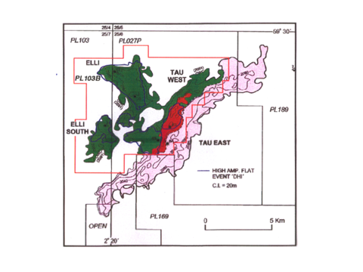

***Fig. 2 Structural cross section in the Jotun area***

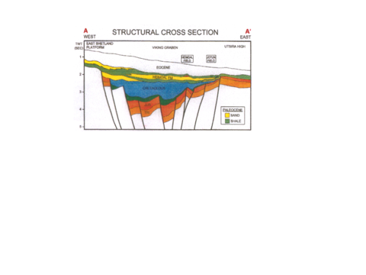

Relevant reservoir data is given in Table 1.

***Table 1 Jotun reservoir data***

|  |  |  |  |  |
| --- | --- | --- | --- | --- |
|  | (kg/m3) | *Boi* (Rm3/Sm3) | *Rs* (Sm3/Sm3) | (kg/Sm3) |
| Elli | 848,7 | 1,14 | 35 | 1,04 |
| Tau | 865,2 | 1,29 | 90 | 1,05 |

Density gradient of water: 0,102 bar/m

Measured pressure data is given in Table 2

***Table 2 Pressure data***

|  |  |  |  |
| --- | --- | --- | --- |
|  | Depth (m) | Elli pressure (bar) | Tau pressure (bar) |
| Oil zone | 2060 | 197,3 | 199,45 |
| Oil zone | 2070 | 198,1 | 200,18 |
| Oil zone | 2080 | 198,86 | 200,9 |
| Water zone | 2110 | 201,53 | 203,53 |
| Water zone | 2120 | 202,55 | 204,55 |
| Water zone | 2130 | 203,57 | 205,57 |

Questions:

1. Use the formula and calculate the density of Elli and Tau oils at reservoir condition
2. Make pressure vs. depth graphs in a spreadsheet and calculate OWC for Elli and Tau
3. Check if the measured pressure oil gradients agree with the oil densities calculated in a)
4. In the same graph, plot the normal water pressure vs. depth according to the formula  (bar) and calculate *C* in the equation (bar) both for Elli and Tau. Explain why the reservoir is underpressured.