

# FACULTY OF SCIENCE AND TECHNOLOGY

**SUBJECT:** Directional Drilling and Flowing Well Engineering - PET 505 **DATE:**  28.11.13

**TIME:** 09.00 – 13.00  **(** 4 hours **)**

**AID:** Calculator, supplied formulas (in exam appendix). Personal notes are not allowed.

**THE EXAM CONSISTS OF 8 PAGES, including the front page**

**Problems on 5 (= 1+4) pages + appendix on 2 (= 1+1) pages**

**REMARKS:**

**General information about the problems:**

NB: DO NOT WRITE YOUR ANSWERS ON THE EXAM SHEET. YOU MUST USE ORDINARY ANSWER SHEETS SUCH THAT WE HAVE TWO COPIES OF YOUR ANSWERS

1. Give short and concise answers.
2. The problems must be answered in the same sequence as given in these exam papers. If answers are given in another sequence, this must be clearly explained.
3. Use of informative figures and sketches will generally improve the answers.
4. Numerical answers must be supplied with explanation and necessary calculations.
5. Acceleration of gravity is g = 9.8 m/s2.

## PART I - MULTIPHASE FLOW

This part constitutes 45 % of the exam. Formulas can be found in the Multiphase Appendix on the next page.

**MULTIPHASE PROBLEM 1**

1. Describe the most common flow regimes that are encountered in horizontal gas-liquid flow in pipelines. Make also a flow regimes map with superficial gas and liquid flow rates as axes. Give values on the axes, and indicate clearly the borderlines between the flow regimes.
2. Gas and liquid flow in a pipe with inner diameter D = 0.1m. The volumetric flowrates are and . Calculate the superficial velocities. The gas fraction is measured independently with a multiphase flowmeter and found to be 0.3. Define the slip ratio and find its value in this case.
3. In laminar flow the velocity profile in pipes is given by . Show that the average velocity is exactly .

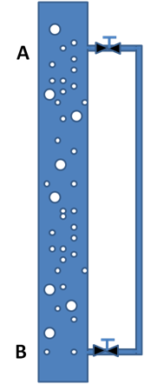**MULTIPHASE PROBLEM 2**

In a vertical pipe as shown to the right, gas and liquid flows upward as dispersed bubble flow in the big pipe. The superficial velocities are 3m/s for liquid and 1 m/s for gas. The pipe inner diameter is 10 cm. Liquid density is 900 kg/m3 and is assumed constant. The gas is assumed ideal and has density 1.2 kg/m3 at reference pressure 1 bar (at temperature as in the pipe here). The viscosity of liquid is 3 cP and gas viscosity is 0.2 cP. The valves leading to the parallel pipe are closed for questions a) and b). The height from A to B is 10 m. The pressure at B is 120 bar.

1. Calculate the gas fraction, the gas density as well as mixture density and viscosity. Use Dukler’s viscosity formula.
2. Calculate the hydrostatic and the friction pressure gradients, using the homogeneous no-slip model. Assume that the pipe is smooth. What is the pressure at A?
3. Later the valves at A and B are opened in such a way that only liquid but ***no gas*** can flow into the parallel pipe. Will there be a flow at all? If so, when flow has stabilized, in what direction will it be in the parallel pipe? Give calculations to support your answer,

**FORMULA APPENDIX – Part I of PET505; Multiphase flow in pipes**

**FLUID PROPERTIES AND PRESSURE CALCULATIONS:**

* Friction factors:

Colebrook and White: 

Dukler: 

* Interface pressure difference : 
* Viscosity models:

McAdams: 

Cichitti: 

Dukler: 

## PART II - Directional Drilling

This part constitutes 45 % of the exam. Formulas can be found in Appendix.

1. Which hole sizes and casings are typically used when constructing a well and when do we run BOP and riser for a subsea well ?
2. The figure below shows a barrier drawing of a production well with gas lift. What are the blue elements shown in the figure below and what purpose do they have ?

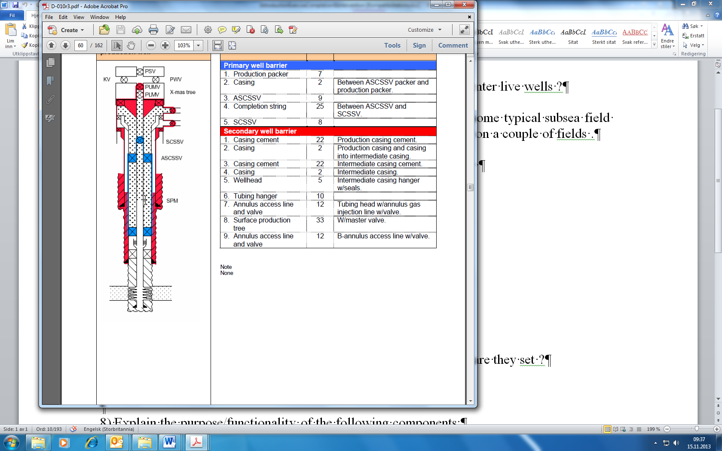

1. Below, we have a PDC bit and a roller cone. Discuss briefly advantages and disadvantages with each.



1. What are the three measurements describing the position of the wellbore and why is there uncertainty in the wellbore position?
2. Which advantages has a rotary steerable assembly vs a motor ?
3. Give examples of typical logging tools, measurements that are conducted while drilling the lower sections.
4. Below we have given some survey data: Calculate dogleg (DL) between the survey points and the dogleg severity (DLS) in the unit deg/10 m Also find the lacking coordinate changes ΔN and ΔV. Here you shall use the minimum curvature method.

|  |  |  |  |  |  |  |  |  |
| --- | --- | --- | --- | --- | --- | --- | --- | --- |
| MD (m) | Δ MD(m) | I (deg) | A (deg) | Dogleg | DLS deg/10 meter | ΔN (m) | ΔE (m) | ΔV(m) |
| 3300 |  | 63,66 | 338,06 | ****** | ***** | ******* | ******* | ****** |
| 3330 | 30 | 64,29 | 339,02 | 1,068 | ? | 25,10 | -9,87 | 13,17 |
| 3360 | 30 | 66,09 | 341,66 | ? | ? | ? | -9,16 | ? |

1. We shall drill a well from a fixed installation in the North Sea. The target coordinates are:

* True vertical depth TVD 3000 meters
* Northing of target = 479.6 m
* Easting of target = 1100 m

1. Calculate the horizontal displacement of the target and the direction of the target (azimuth)
2. The inclination in the sail/hold section shall be constant 45 degrees. The build up rate is. Show how we can derive the formula  (See figure below) and use this to find R.

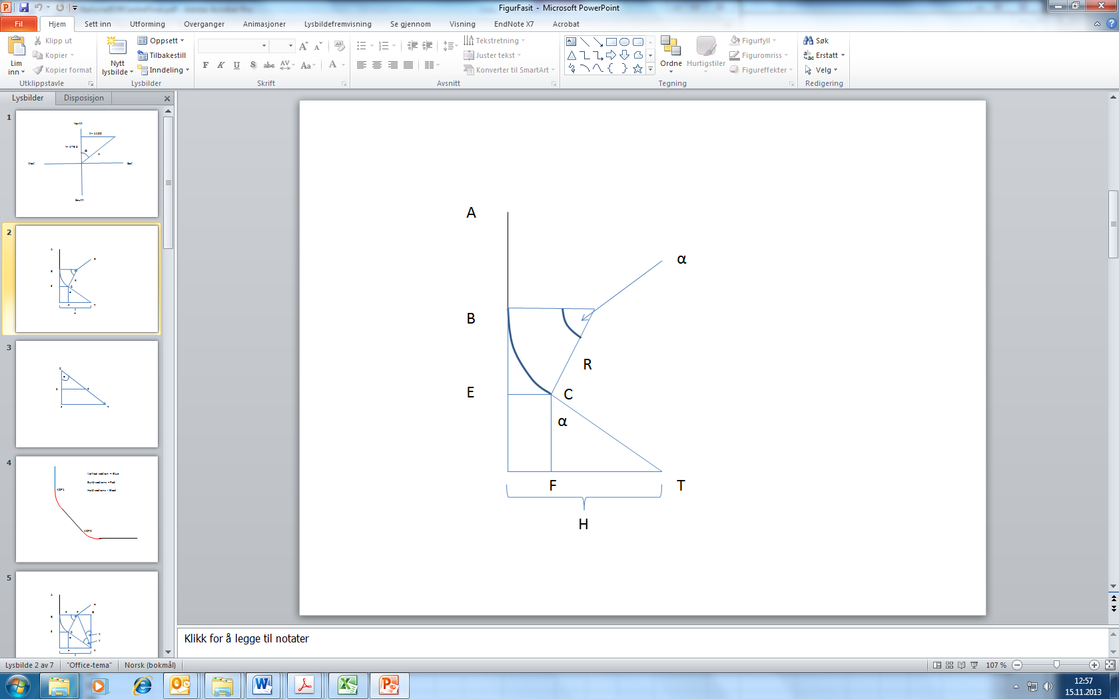

1. What is the depth of the kick off point (KOP)?
2. We are drilling in direction West and the inclination is 6 degrees. We have a motor that can change angle with 3 deg/30 meters. We want to turn the well to the north (increase azimuth from 270 degrees). Draw a Ragland diagram and perform necessary calculation to answer the following two questions.

a) What is the maximum azimuth change that can be achieved after drilling one stand (30 meters) ?

b) What will the toolface be in this case ?

**NB! Don’t forget the well friction problem on next page.**

## Well friction

This part constitutes 10 % of exam.

Below is a pipe inside a well.

1. Draw the forces acting on the pipe. Derive an equation for the force F2 when the pipe is hoisted up or lowered into the well.
2. At an angle of 70 degrees the pipe stops to move when run into the well. Determine the coefficient of friction.



1. Below is a deviated well. The pipe weight including buoyancy is 900 N/meter of pipe. The measured length of the pipe is 1700 m, the vertical depth is 1000 m and the horizontal departure is 1300 m.

Determine the static hook load if friction is neglected.



# Appendix A – Formulas

**Formula for dogleg (DL):**



**Conversion between radians and degrees:**



**Minimum Curvature Method:**



**Ragland formulas**







DL – Dogleg, TF – Toolface, A –Azimuth, I-Inclination

**Units**

1 inch =2.54 cm = 0.0254 m

1 feet = 0.3048 m

1 bar = 100000 Pa = 14.5 psi

1 sg = 1 kg/l (sg - specific gravity)