

# FACULTY OF SCIENCE AND TECHNOLOGY

**SUBJECT:** Directional Drilling and Flowing Well Engineering - PET 505 **DATE:**  24.02.14

**TIME:** 09.00 – 13.00  **(** 4 hours **)**

**AID:** Calculator, supplied formulas (in exam appendix). Personal notes are not allowed.

**THE EXAM CONSISTS OF 8 PAGES, including the front page**

**Problems on 5 (= 1+4) pages + appendix on 2 (= 1+1) pages**

**REMARKS:**

**General information about the problems:**

NB: DO NOT WRITE YOUR ANSWERS ON THE EXAM SHEET. YOU MUST USE ORDINARY ANSWER SHEETS SUCH THAT WE HAVE TWO COPIES OF YOUR ANSWERS

1. Give short and concise answers.
2. The problems must be answered in the same sequence as given in these exam papers. If answers are given in another sequence, this must be clearly explained.
3. Use of informative figures and sketches will generally improve the answers.
4. Numerical answers must be supplied with explanation and necessary calculations.
5. Acceleration of gravity is g = 9.8 m/s2.

## PART I - MULTIPHASE FLOW

This part constitutes 45 % of the exam. Formulas can be found in the Multiphase Appendix on the next page.

**MULTIPHASE PROBLEM 1**

1. Describe the most common flow regimes that are encountered in vertical gas-liquid flow in pipelines. Make also a flow regimes map with superficial gas and liquid flow rates as axes. Give values on the axes, and indicate clearly the borderlines between the flow regimes.
2. Gas and liquid flow in a pipe with inner diameter D = 0.1m. The volumetric flowrates are  and . Calculate the superficial velocities. The gas fraction is measured independently with a multiphase flowmeter and found to be 0.25. Define the slip ratio and find its value in this case.
3. In laminar flow the velocity profile in pipes is given by . Find the volumetric flowrate for a pipe with diameter 10cm, and umax = 2 m/s.

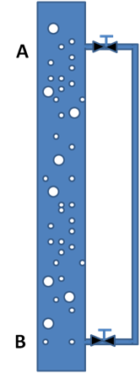**MULTIPHASE PROBLEM 2**

In a vertical pipe as shown to the right, gas and liquid flows upward as dispersed bubble flow in the big pipe. The superficial velocities are 3.5 m/s for liquid and 0.8 m/s for gas. The pipe inner diameter is 10 cm. Liquid density is 800 kg/m3 and is assumed constant. The gas is assumed ideal and has density 1.2 kg/m3 at a given reference pressure 1 bar (at the same temperature as in the pipe here). The viscosity of liquid is 3 cP and gas viscosity is 0.2 cP. The valves leading to the parallel pipe are closed for questions a) and b). The height from A to B is 10 m. The pressure at A is 110 bar. The small pipe has diameter 1cm.

1. Calculate the gas fraction, the gas density as well as mixture density and viscosity. Use Dukler’s viscosity formula.
2. Calculate the hydrostatic and the friction pressure gradients, using the homogeneous no-slip model. Assume that the pipe is smooth. What is the pressure at B?
3. Later the valves at A and B are opened in such a way that only liquid but ***no gas*** can flow into the parallel pipe. Find the flow speed and the flow direction in this small pipe? Neglect friction in valves and the horizontal connectors. Assume laminar flow, but check if it is ok.

**FORMULA APPENDIX – Part I of PET505; Multiphase flow in pipes**

**FLUID PROPERTIES AND PRESSURE CALCULATIONS:**

* Friction factors:

Colebrook and White: 

Dukler: 

* Interface pressure difference : 
* Viscosity models:

McAdams: 

Cichitti: 

Dukler: 

## PART II - Directional Drilling

This part constitutes 45 % of the exam. Formulas can be found in Appendix.

1. The following figure shows the pore and fracture pressure for a given stratigraphic column.

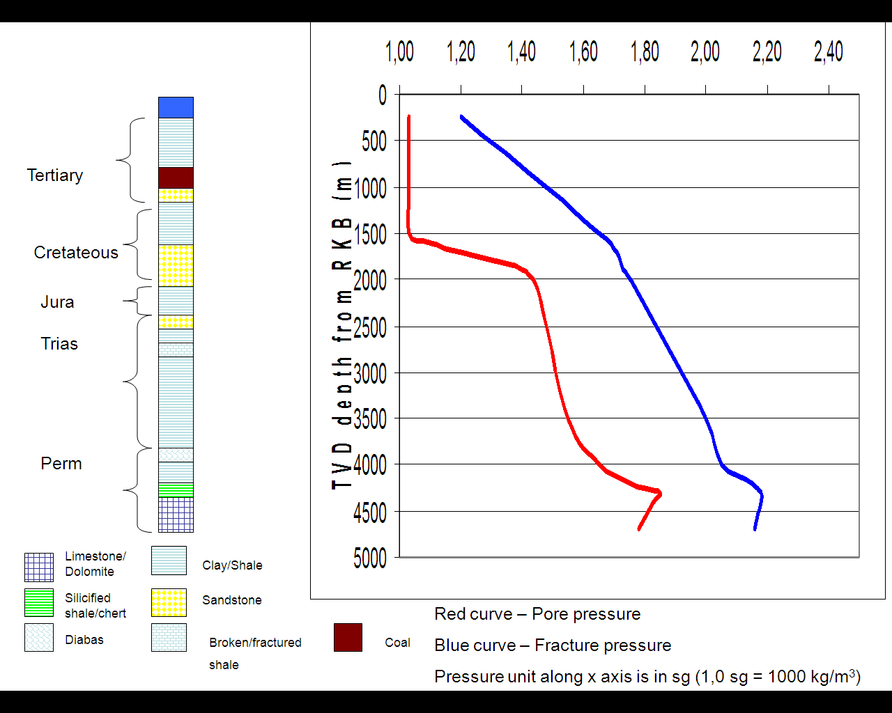

Give a proposal for where you want to set the different casing shoes !

|  |  |  |
| --- | --- | --- |
| Hole section | Casing size | Setting depth from RKB (m) |
| 36” | 30” | ? |
| 26” | 18 5/8” | ? |
| 17 ½” | 13 3/8” | ? |
| 12 ¼” | 9 5/8” | ? |
| 8 ½” | 7” liner | ? |

Explain the purpose/functionality of the following components:

* Packer fluid
* Production tubing
* PBR
* Sliding sleeve
* Nipple/ locking mandrel

1. What are the different types of vibrations that can occur in the bottomhole assembly? Make a figure to illustrate these! Also discuss what kind of vibrations the Roller Cone and the PDC bit can typically experience!
2. Name six reasons for when it is preferential to perform directional drilling!
3. What is vertical section ? (You can try to draw figures to illustrate this)
4. Explain how logging tools are used in the geosteering process where you also discuss the challenges with drilling into a fault
5. During a build up, two measurements are taken:

|  |  |  |
| --- | --- | --- |
| Measured depth MD (m) | Inclination I | Azimuth A |
| 921 | 17 | 163 |
| 950 | 18 | 165 |

1. Calculate the dogleg!
2. Calculate the dogleg severity (in unit deg/30 meter)!
3. A well shall be drilled vertical down to KOP1. After that there will be a hold section until one reaches KOP2. One will then start to build angle such that the well will be horizontal when entering the reservoir. Build up rates are: . We have also given: 

KOP1: (1300 m TVD, 1300 m MD)

KOP2: (580 m North, 1550 m East, 3700 m TVD)

1. Make a sketch of the well and calculate azimuth and horizontal displacement for KOP2!
2. Calculate maximum inclination after the first build up!
3. Calculate the measured depth (MD) at KOP2 ! (NB, if an answer was not found in b), just assume that the maximum inclination is 40 degrees)

9) During drilling, it was seen necessary to adjust the well path. A correction run with a positive displacement motor and a bent sub had to be carried out. This tool is able to change angle withThe present inclination is 6 degrees and the azimuth is 180 degrees. The toolface is set at 60 degrees to the right of high side.

We want to find the new inclination and the new azimuth after drilling two stands (60 meters) using the correction tool.

1. Draw a Ragland Diagram and solve this problem graphically!
2. Use formulas in Appendix to verify your graphical solution

**NB! Don’t forget the well friction problem on next page.**

## Well friction

This part constitutes 10 % of exam.

Below is a pipe inside a well.

1. Draw the forces acting on the pipe. Derive an equation for the force F2 when the pipe is hoisted up or lowered into the well.
2. At an angle of 70 degrees the pipe stops to move when run into the well. Determine the coefficient of friction.



1. Below is a deviated well. The pipe weight including buoyancy is 900 N/meter of pipe. The measured length of the pipe is 1700 m, the vertical depth is 1000 m and the horizontal departure is 1300 m.

Determine the static hook load if friction is neglected.



# Appendix A – Formulas

**Formula for dogleg (DL):**



**Conversion between radians and degrees:**



**Minimum Curvature Method:**



**Ragland formulas**







DL – Dogleg, TF – Toolface, A –Azimuth, I-Inclination

**Units**

1 inch =2.54 cm = 0.0254 m

1 feet = 0.3048 m

1 bar = 100000 Pa = 14.5 psi

1 sg = 1 kg/l (sg - specific gravity)