Faculty of Science and Technology
Institute of Petroleum Technology

EXAMINATION: BIP210 Well logging DATE: 06.06.14

TIME OF EXAMINATION: 3 hours

EXAMINATION IN NORWEGIAN AND ENGLISH
We recommend you to answer in English.
AUTHORIZED HELP:
- Simple calculator (Casio FX-82, TI-30 or HP30S)
- Language dictionary between your mother tongue and English

The exam consists of total of 9 pages: 3 pages consisting of 3 exercises plus 5 pages of 4 enclosures. The enclosures must be handed in with the answers.

Exercise 1 – Sonic Log
Use short answers and sketches.

- What are the acoustic waves detected by the sonic tool? Describe each of them using sketches.

- What is the Snell’s law and which principle is used for the sonic tool? Explain using sketches.

- BHC tool:
  - Describe the functioning of the Borehole Compensated tool using sketches.
  - How is computed the slowness?
- Newer tools: (use sketches)
  - What are the main difference between BHC and the newer tools
  - Then, how is computed the slowness?

- What are the difficulties for using LWD sonic tools?

- What is the impact of high pressure zones on the sonic log? Illustrate with sketches.

  - How do we calculate porosity using the sonic log?
  - Do we need to correct the sonic porosity for sandstones? If so, explain what this correction is.
- Use sketches to illustrate.
  - What do we call seismic lithology?
  - Show how the density log and sonic log can be used in seismic lithology.
- Illustrate using sketches.
  - Why do we need a time-depth conversion?
  - What is a vertical seismic profile VSP?

Exercise 2

- What are the main differences between natural and drilling induced fractured. Cite at least 5 examples. If possible use sketches.
- A fractured reservoir shows natural fractures saturated in oil oriented vertically. How should be positioned the well in order to produce the maximum of oil from the fractures? Illustrate with sketches.

  - What is a break out? What are the differences between drilling induced fractures and break out? Use sketches.
  - Which logging tools do we use to characterize a break out?
- Which tools can create image logs in:
  - WL?
  - LWD?
  - What is the reason of more imaging tools in LWD than in WL?
  - Is the resolution between WL and LWD image the same?
- What represents the color scale (dark and light colors) in:
  - Electrical image logs?
  - Acoustic image logs?
- Figure 2.1 and 2.2 are electrical image logs and Figure 2.3 is an acoustic image log.
  - Interpret the main beds (with associated lithologies), natural and/or drilling induced fractures and/or break out on each figure. Precise if the fractures are open or cemented.
  - For each figure, plot the dip and azimuth of the identified beds and/or fractures on the tadpole graph.

Exercise 3 – Well evaluation
From the well 8/4-1 in the North Sea, the following wireline logs are given for an interval from 2375m to 2630m (Figure 3 on 2 pages):
- Gamma log
- Density log
- Neutron log
- Sonic log
- Resistivity log

- Mark the lithology in the depth track for the log interval on pages 7 and 8.
- Between 2550 and 2575m there are two peaks A-A, explain them.
- There is no gas in this well. Mark the oil zone for the reservoir.

- For this oil zone:
  - Compute the porosity using three methods.
  - Compute the water saturation using only the porosity from the density log.

- Is there vertical communication through the whole log interval? Why?

  - What is the Net Sand?
  - Mark the net sand zone on the logs

4 ENCLOSURES of 5 pages

The 4 enclosures (5 pages) must be handed in with the answers

ENCLOSURE 1 – FIGURE 2.1
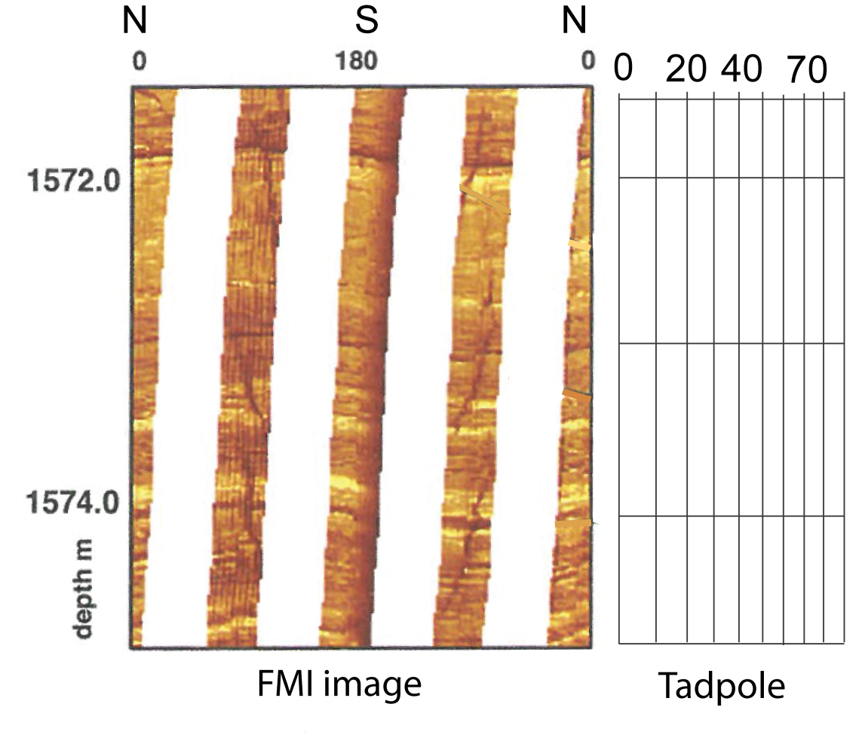

FIGURE 2.2
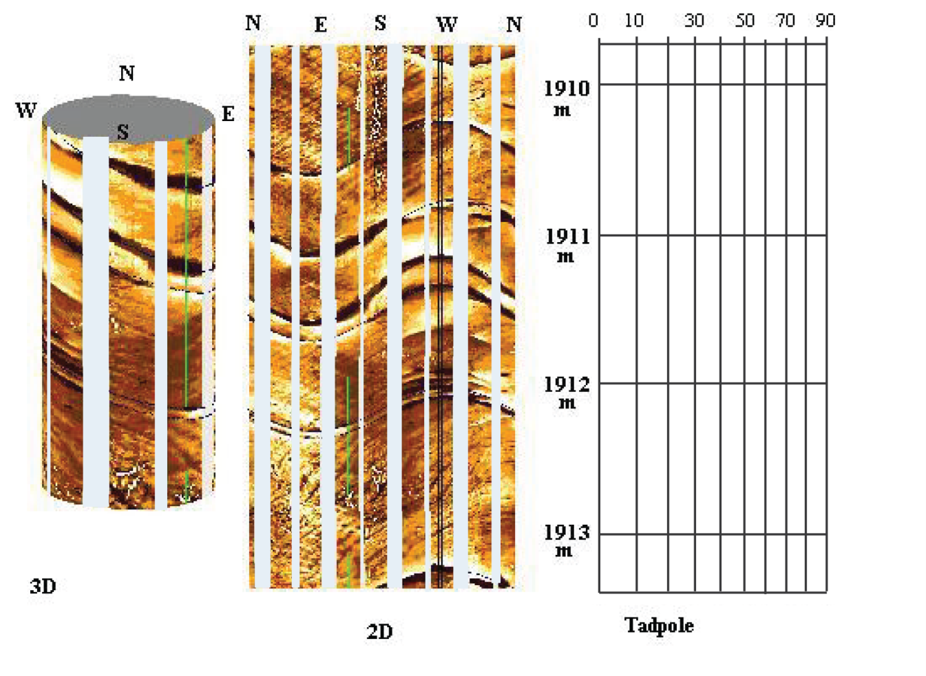

ENCLOSURE 2 – FIGURE 2.4
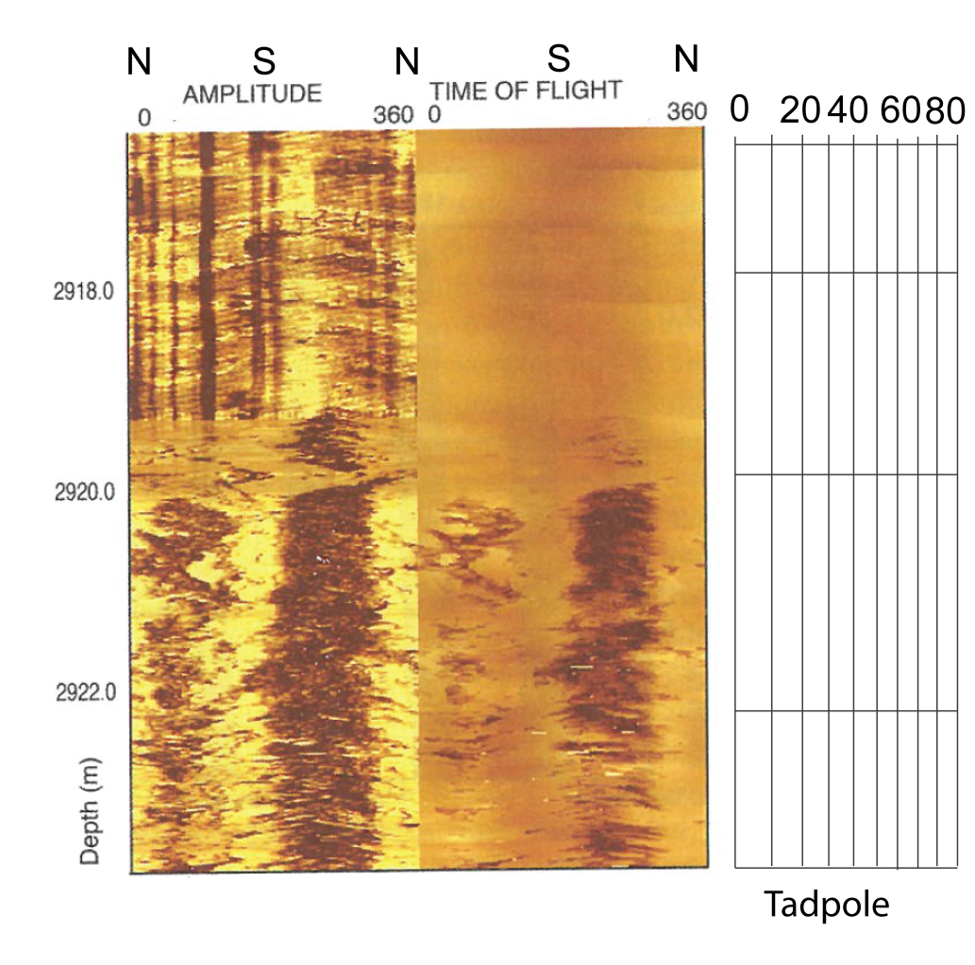
ENCLOSURE 3 – FIGURE 3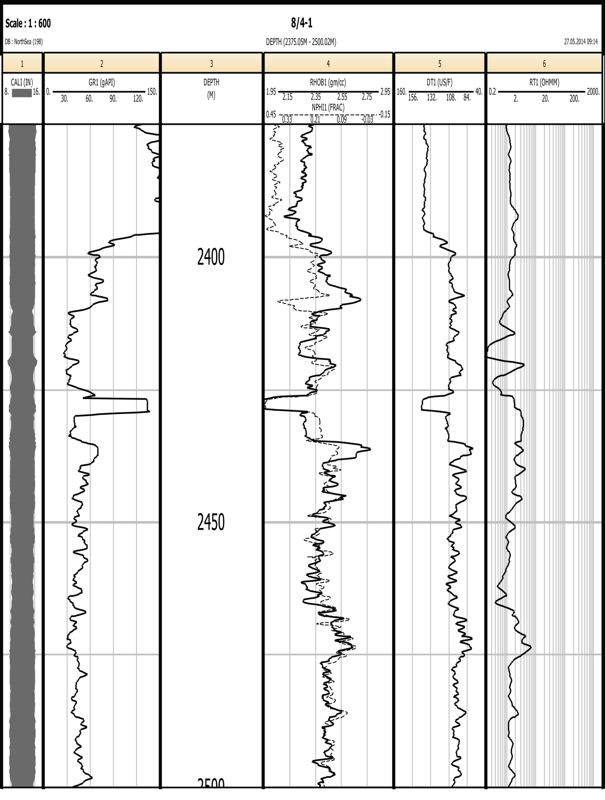
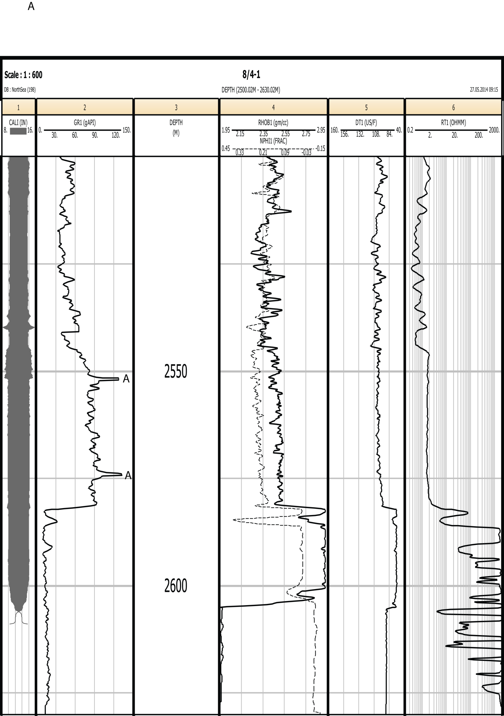

ENCLOSURE 4