PVT reservoir geology

The petroleum system, their geological components and key processes, estimating petroleum resources and reserves
Elements:
- Source rock
- Migration route
- Reservoir rock
- Seal rock
- Trap

Processes
- Generation
- Migration
- Accumulation
- P reservation

Petroleum system:

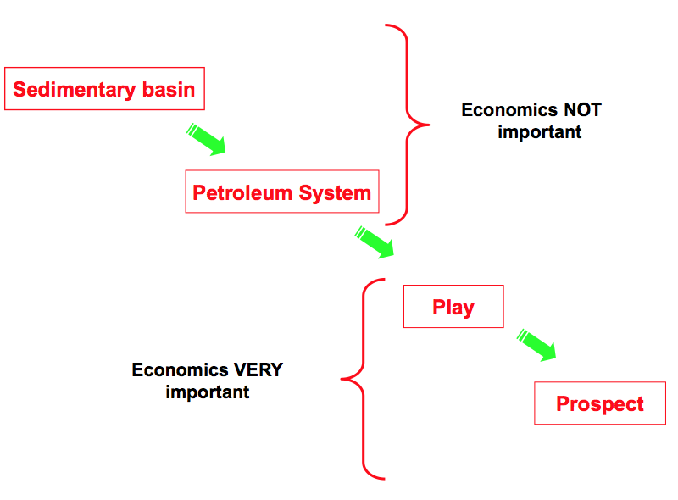
Ex the Kimmerigdian source rock

Play:
Ex mid Jurassic reservoir type.

Reservoir description
- Characterize the reservoir boundaries and internal properties in order to estimate the In-Place hydrocarbon resources
- Generate a static reservoir model (skeleton) that will be used for reservoir simulation in order to plan the development strategy and amount of recoverable resources
- Systematically identify remaining hydrocarbons in producing reservoirs. This work is done interactively between the reservoir engineer and the reservoir geoscientist.

Reserves (proven producible volumes of oil and gas):

$$Reserves=STOIIP*Recovery factor$$

$$STIOIP=\frac{GRV*NTG*PORO*(1-S_{W})}{B_{o}}$$
STOIIP: Stock tank oil initial in place
GRV: Gross rock volume
NTG: Net to gross
PORO: Porosity
S_{w} : Water saturation
B_{o} : Compressional factor as oil (gas) brought to surface

Sedimentarys, tectonic settings, the cause of subsidence and isostasy
Sedimentary basins are regions of the earth of long-term subsidence creating accommodation space for infilling by sediments. Sedimentary basins occur in diverse geological settings usually associated with plate tectonic activity. Basins are classified structurally in various ways, with a primary classifications distinguishing among basins formed in various plate tectonic regime (divergent, convergent, transform, intraplate), the proximity of the basin to the active plate margins, and whether oceanic, continental or transition crust underlies the basin.
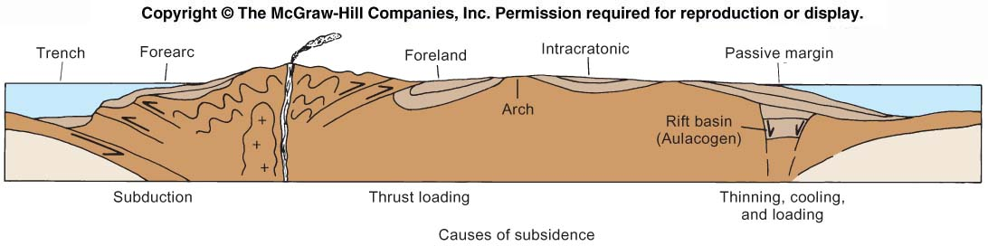
Basin classification
- Active margin
  - Back-arc basin, fore-arc basin, foreland basin, trench basin, rift basin
- Intracontinental basins
  - Passive continental basins
  - Failed rift basins

Subsidence mechanism:
- Related to cooling
  - Passive continental margin
- Related to crustal thinning
- Subduction subsidence
- Loading
  - Glacial, sediments, thrust loading
EKSEMPLER PÅ BASINS

Plate tectonic:

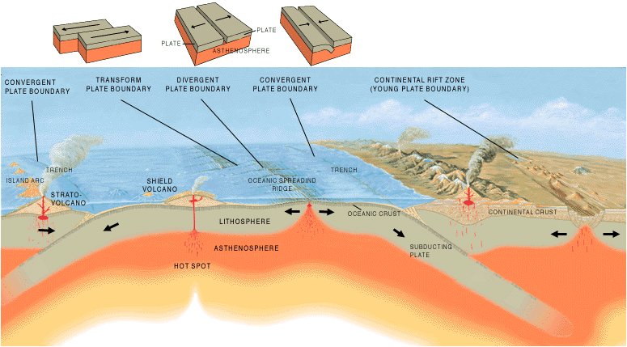

An active continental margin is found on the leading edge of the continent where it is crashing into an oceanic plate. Passive continental margins are found along the remaining coastlines. Because there is no collision or subduction taking place, tectonic activity is minimal and the earth's weathering and erosional processes are winning. This leads to lots of low-relief (flat) land extending both directions from the beach, long river systems, and the accumulation of thick piles of sedimentary debris on the relatively wide continental shelves.

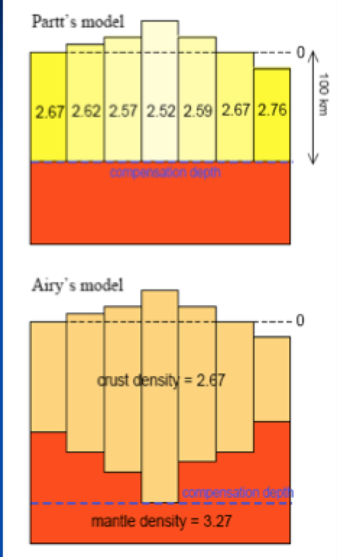
Isostasy: Balance of forces: equilibrium between lithospheric segments (plates) and asthenosphere which lies beneath. This concept is invoked to explain how different topographic heights can exist at the Earth's surface. When a certain area of lithosphere reaches the state of isostasy, it is said to be in isostatic equilibrium. Isostasy is not a process that upsets equilibrium, but instead is one which restores it.

$$\sum{{\left(ρgh\right)}_{1}}=\sum{{\left(ρgh\right)}_{2}}$$

Accommodation of space:
$$\sum_{n=0}^{∞}{W}\left[\frac{ρ_{s}-ρ_{w}}{ρ_{m}} \right]$$
s = sediment, w = water, m = mantle

Reservoir geology, theoretical concepts including Walter’s law, sandstone deposits environments, fluvial channel types, marine fan systems lateral connectivity and net-to-gross properties.
Depositional systems:
Assemblage of multiple process-related sedimentary facies assemblages, commonly identified by the geographic in which deposition occurs. This are modern features and are used to interpret ancient sedimentary successions.

Walter’s law:
“A comparable vertical sequence of facies was generated by a lateral sequence of environments” (best)
“Facies occurring in a conformable vertical sequence were formed in laterally adjacent environments”
Facies successions:
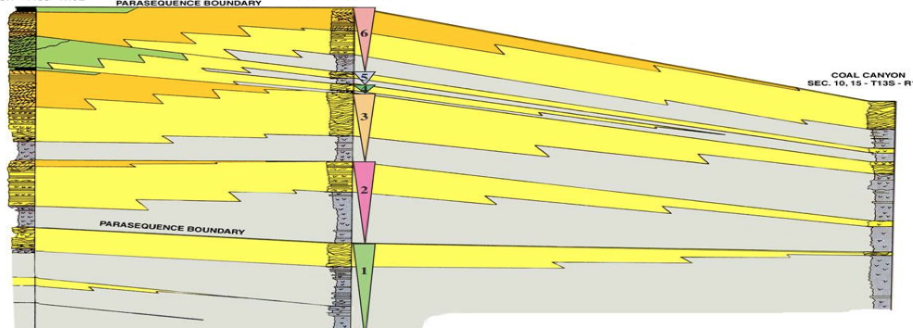

Costal deposits

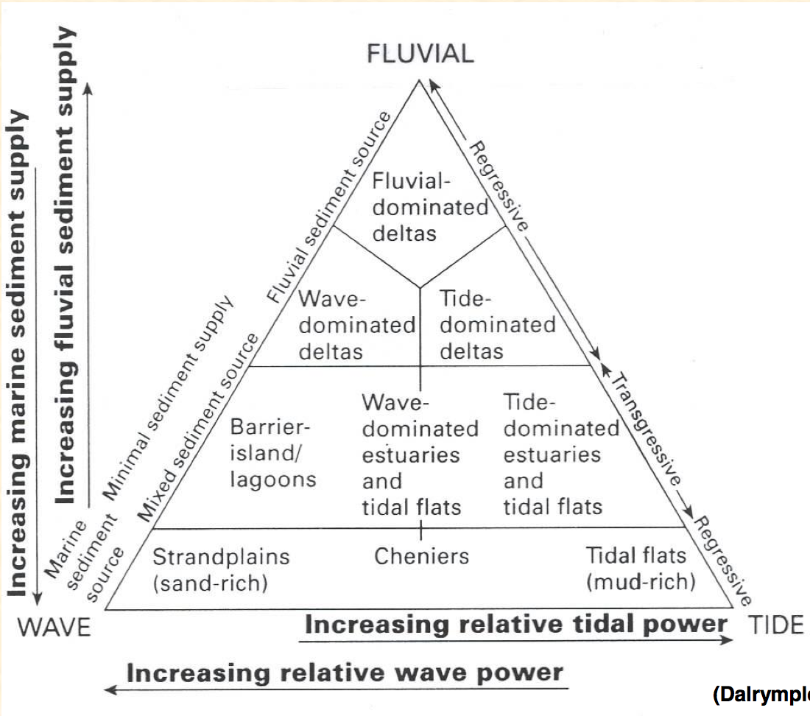
Marine fan systems

Delta systems (costal/shallow marine):
The delta area is were a significant amount of sediments are transported by a river entering a basin. This is a transition zone between subarial and marine sedimentation. The size of the delta depends on the drainage area and they content of abundant reservoir rock.

The delta can be divided into three different:
- Fuvial dominated
  - Ex Mississippi delta (GoM)
- Wavedomenated
  - Ex Nile delta
- Tidel dominated
  - Ex Amazon delta

Tide and wave dominated:
Coastal reservoirs:
- Laterally extensive
- Locally developed highly heterolithic
- Large share of global HC’s are in these reservoir
  - Ex low mid jura
    - Brent group (statfjord Fm)
    - Rogn, Garn, Ile Fms
    - Stø, Nordmela, Snadd Fm
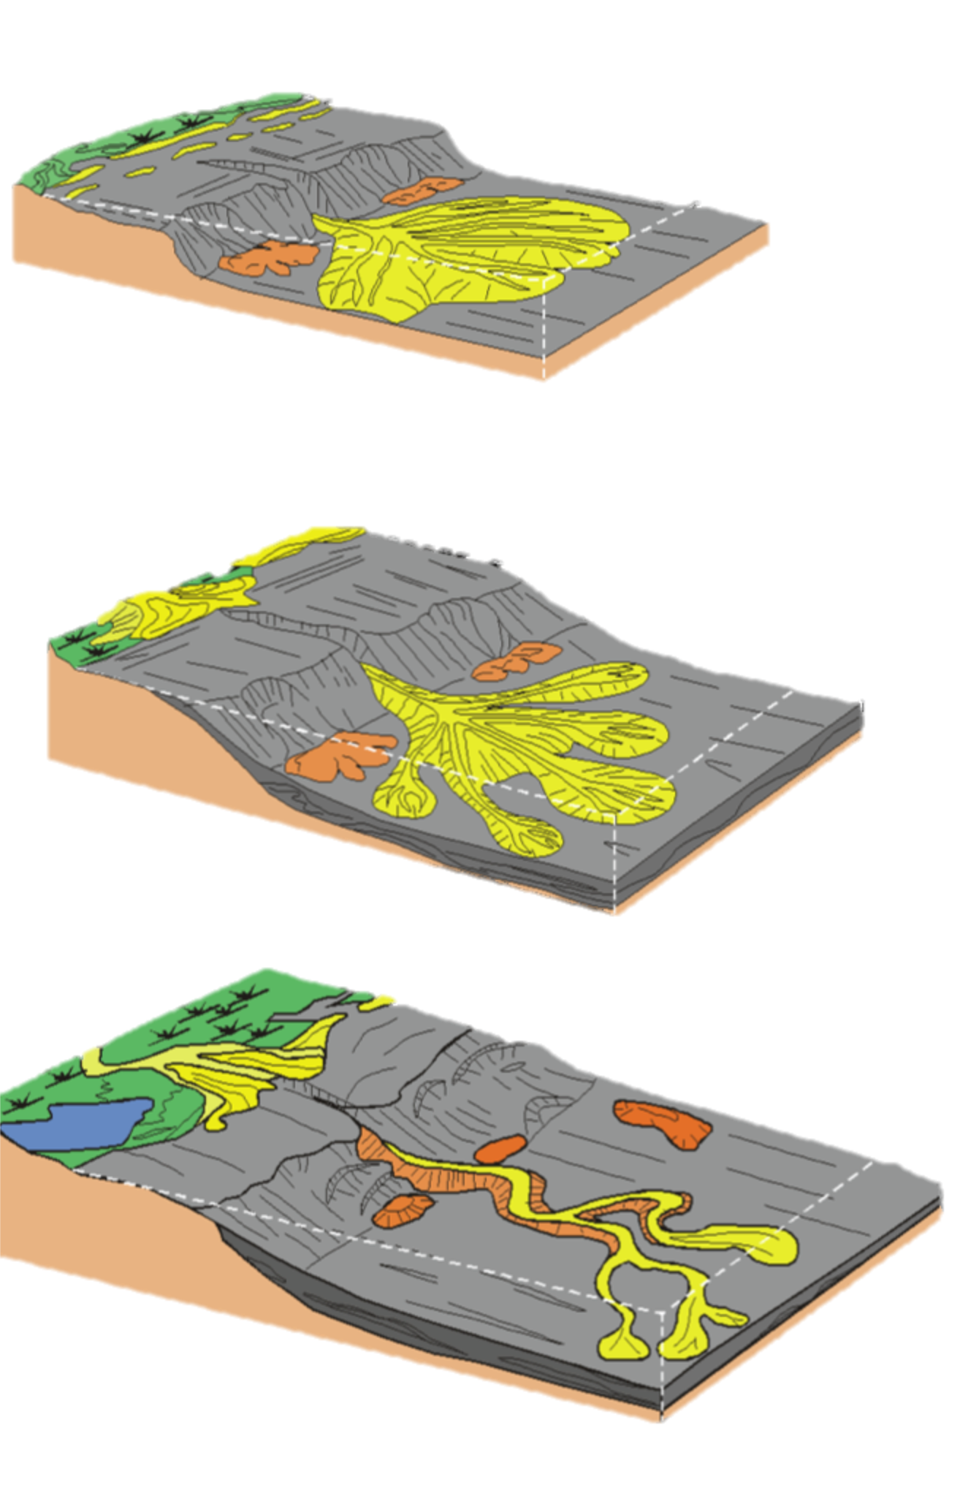
Deep marine systems:
Sand rich fans
- With tectonic active areas
- Narrow shelf, steep angle
- Narrow slope with multiple entry points
- Moderate-sized high net to gross fan

Mixed sand/mud fan:
- Large mixed load
- Muddy shelf
- Canyon-head retreat into sand-rich-shelf
- Moderate-sized mixed-load fan

Mud rich fan
- Fluvial dominated deltas
- Broad muddy shelf
- Broad low angle slope
- Large muddy to mixed load fan

Reservoir Architecture:

Sand-rich
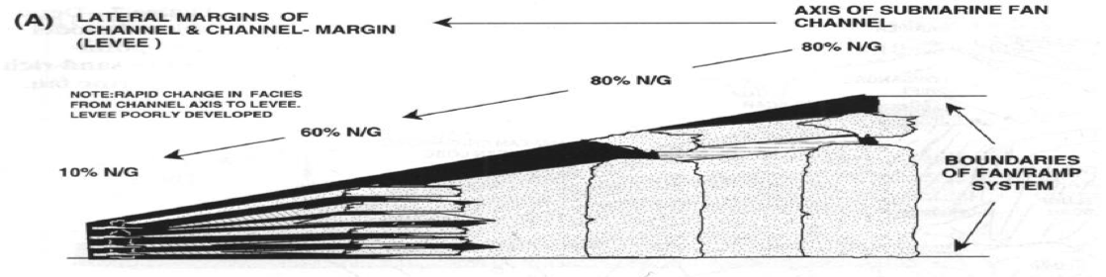
Mixed sand/mud
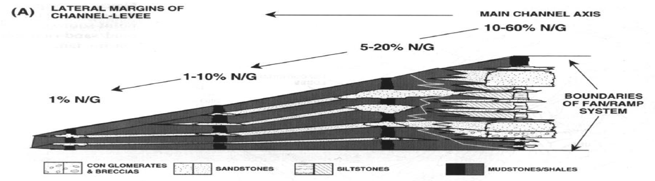

Mud rich
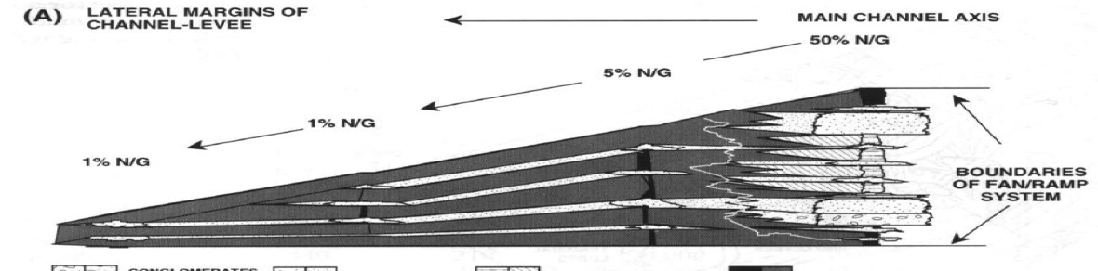
Fluvial system
Channel system:

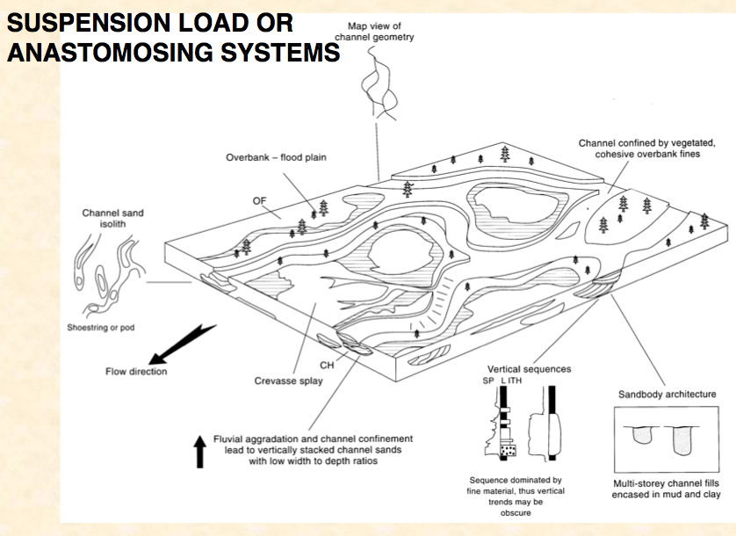
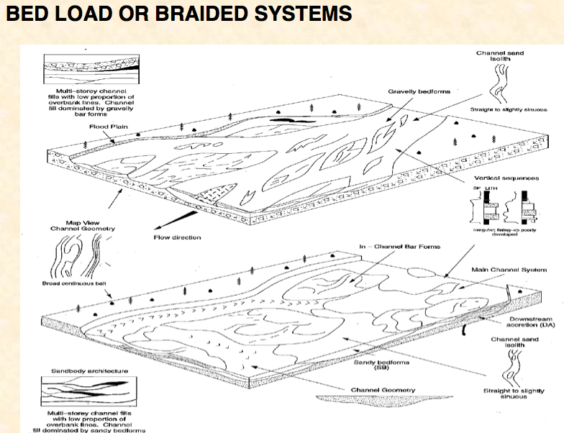
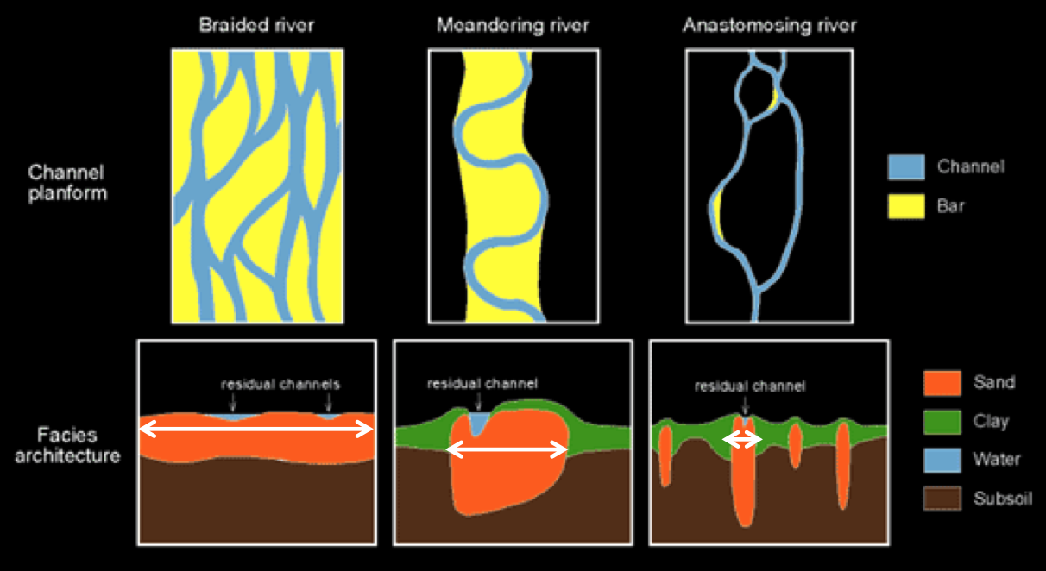
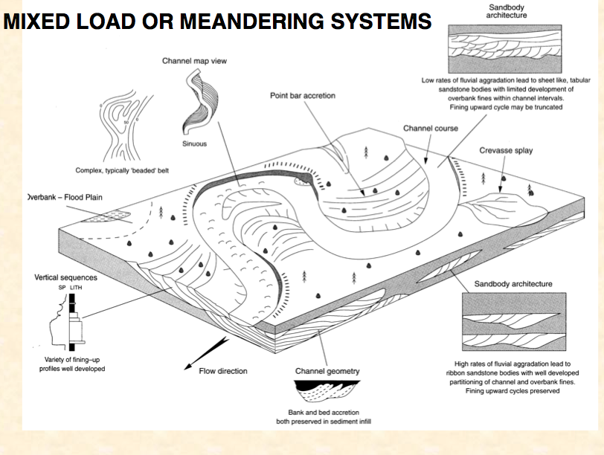

Dessert:
Aeolian dunes:
- Excellent reservoir (but source rock must be deposited before)
- Evaporites seal possible
- 10-100m thick common
- Laterally extensive
- Permeability can be impaired by diagenetic minerals

North sea chalk reservoir quality and how they compare to more typical carbonates reservoir world-wide
General carbonated reservoir
- 20% of world reservoir
- 50% of worlds reserves
- Related to 80-120 ºC
- Evaporites seal important

Porosity vs depth
- Extremely heterogeneity
- Lower P10, P50 and P90 compared to sandstone reservoir
- North sea show higher porosity than the global
- Porosity rates vs depth equal to sandstone

Porosity vs permeability
- Extremely heterogeneity
- North sea chalks show lower permeable trend
- Fracture important at low porosity

Anomalously high primary porosities have been maintained in Norwegian North Sea chalks where the effects of mechanical and chemical compaction have been limited. The diagenetic pathway of a chalk reflects changes brought about by mechanical and chemical compaction. Five factors most heavily influence the diagenetic pathway:
- Burial depth
- Chalk type
- Overpressuring
- Presence of hydrocarbons
- Original grain size.

North-sea preservation of high porosity
- Creation of a rigid grain-to-grain framework due to the early cementation
- Early hydrocarbon charge, which inhibits or even stop chemical compaction
- Overpressure due to rapid subsidence
The chalk is rather pure CaCO₃, but more clay rich intervals occur in the north sea reservoirs, forming a tight low-permeability zone.

Diagenesis, particularly in sandstone, and geological controls on reservoir quality, including sand grain size, composition, sorting and burial history
Diagenesis:
All changes undergone by a sediment after its initial deposition, exclusive of weathering or metamorphism. It is any chemical, physical, or biological change undergone by a sediment after its initial deposition, after its lithification.

Diagenesis in clay/mudstone
Initiated at 60 to 80 ºC
- > 60
  - Risk of overpressure development
  - The probability of hydrocarbon charge increases
  - Risk of biodegradation decreases
    - Chemical dissolution of material by bacteria or biological means
- >120
  - Rates of quartz cementational porosity loss, risk of hard overpressure, seal failure & gas/oil remigration increases exponentially.

The golden zone chemical seal:
Shale > 60 ºC:
$${Smectite}/{Kaolinite} + K Feldspar \overset{Precipitation}{\overbrace{→} } Illite$$

causes permeability reduction due to pervasive pore-bridging illite

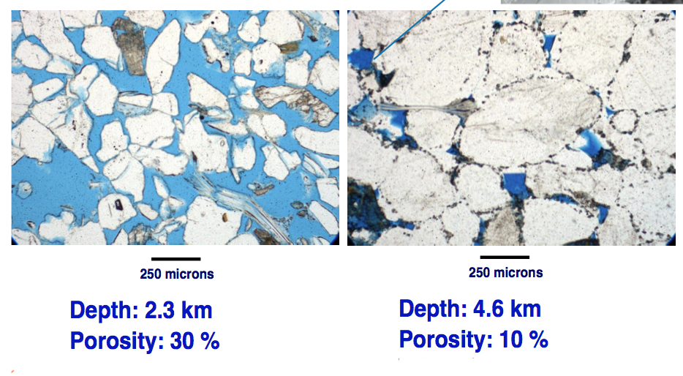
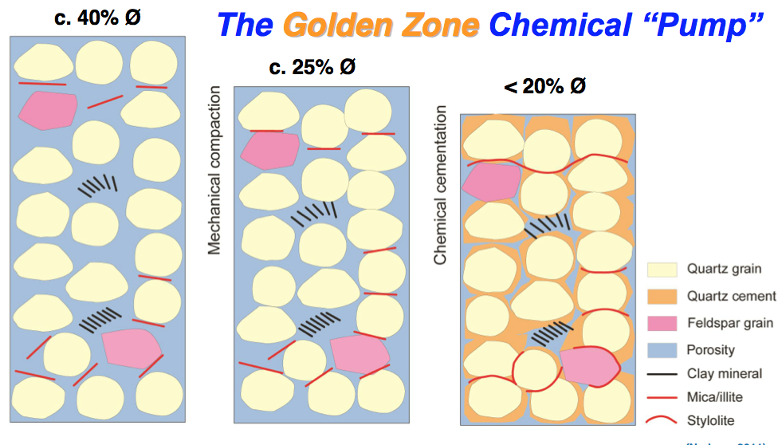
Diagenesis in sandstone – quartz cementation
- Mechanical compaction
  - Porosity decreases
- Chemical cementation
  - Porosity decreases

Porosity loss rates: linear to quartz surface area and exponential to the temperature.
Steady until 120 ºC (0,2% /My)
> 120 increases more (ex 160 1,8%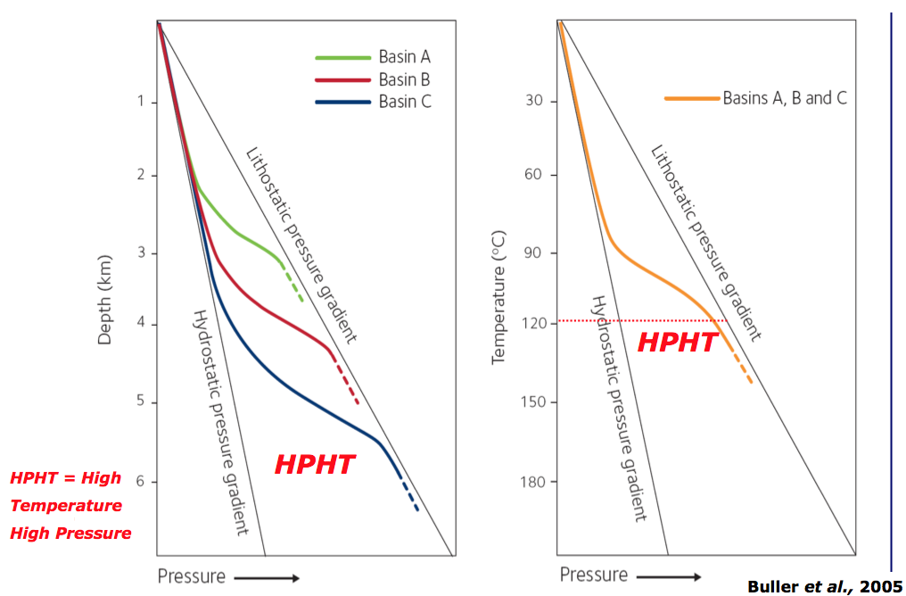

Reservoir quality
Excellent sandstone reservoir has
- Intra granular grains
- Well sorted grains
- Medium size grains
- Absence of any clay in pore space.
This is resulting in very good porosity (e.g. 30%) and permeability excess in Darcy.

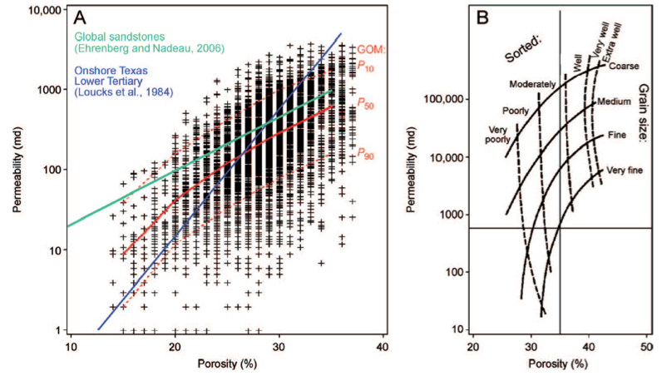

Relationship between reservoir temperature, pressure and fluid types
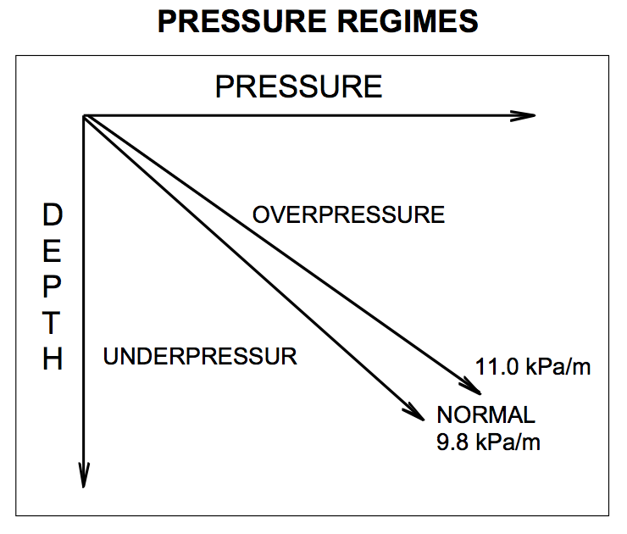
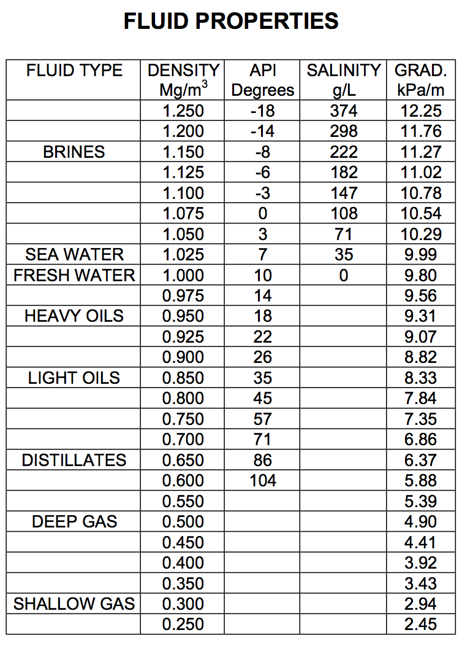

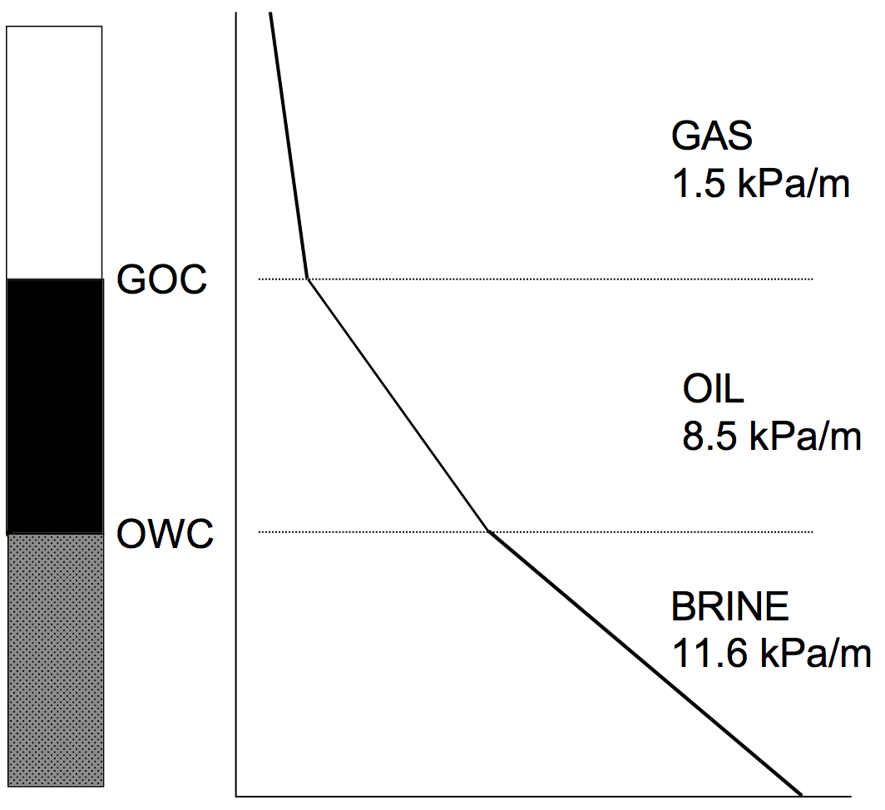
Source of abnormal pressures:
- Rapid geological loading (deposition) or unloading (erosion) creating compaction (consolidation) disequilibrium.
- Thermal expansion of fluids
- Regional compressive (squeezing) or tensile (stretching) tectonic stresses
- Generation of oil and gas from organic mater

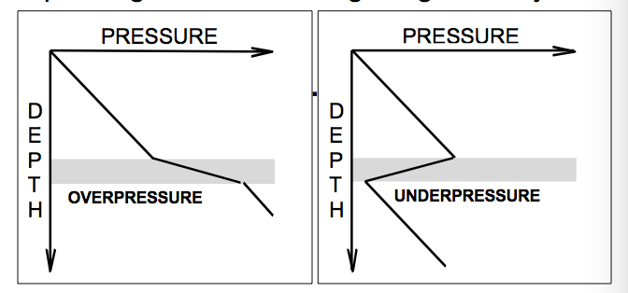
The pressure disequilibrium can create overpressure or underpressure:

Seismic interpretation and processing with respect to reservoir and fluid effects

P – Wave compressional wave
S – Wave Shear wave
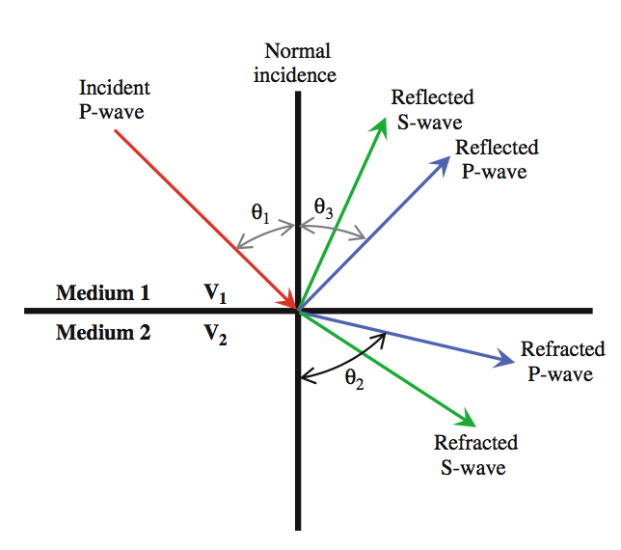
S waves do not travel through fluid, as fluid has no shearing capacity.
Snell’s law:
$$\frac{\sin{θ_{1}}}{\sin{θ_{2}}}=\frac{V_{2}}{V_{1}}$$
Which describes the changes in the direction of a wave front as it travels in media of different velocities. How much energy which is reflected depends on the impedance ( P-impedance and S-impedance). Reflection coefficient:
$$R=\frac{ρ_{2}V_{2}-ρ_{1}V_{1}}{ρ_{2}V_{2}+ρ_{1}V_{1}}$$

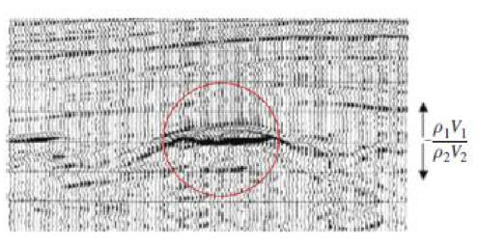
Shows a large impedance contrast in the red zone, which corresponds to big change in lithology or fluid properties. Ex: Limestone tends to have both high velocities and high densities, put this in contrast with shale the impedance will be great.

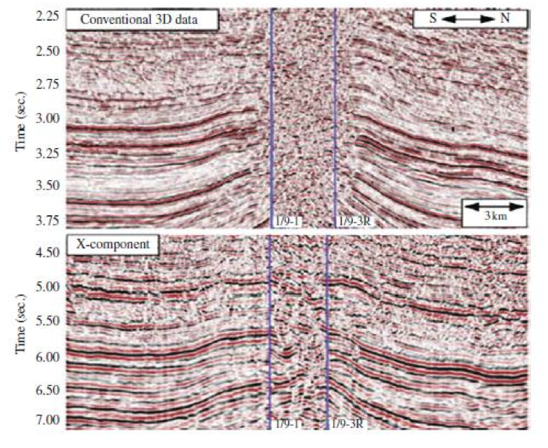
Top:
P-P stack (compressional P-wave) of conventional 3D streamer. This can also be justified because P-waves are faster than S-waves and we see that the to-way-time is less on the upper plot.

Bottom:
P-S of OBS data. This is converted shear wave. PS data have successfully been used to image through gas clouds and image reflectors that are weak on the PP data. S-waves data reduces the effect of shallow gas. Furthermore, the zone must be gas, because S-waves don’t travel in fluid.

Ocean-bottom cable (OBC) methods record both compressional (PP) and converted shear-wave (PS) data. PS data have successfully been used to image through gas clouds (Xiang-Yang Li et al., 2001) and image reflectors that are weak on PP data ( MacLeod et al., 1999), and can help constrain rock property estimates (Özdemir et al., 2001). Thus, in principle, the use of PS data can significantly mitigate risk in hydrocarbon exploration and production. However, imaging of PS data relies upon accurate compressional and shear velocity estimates, as both the moveout and offset of the imaged point depend upon these parameters.
Velocity anisotropy is also a critical factor. Previously used processing flows have not adequately comprehended this, and the results have often been of poor quality and difficult to tie with the PP volumes. This can preclude their use for lithology prediction. Our imaging workflow can resolve many of these issues.

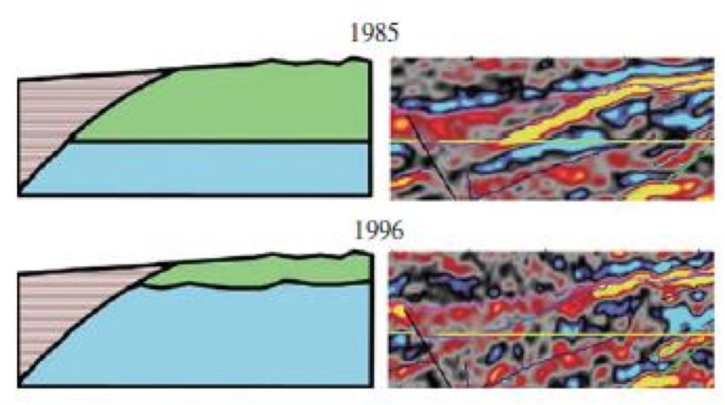
The green is oil and blue water. Can see clearly on the seismic that the OWC has been moved up throughout the year of production. The effect of replacing oil with water is evident on this figure, and is further strengthened by the amplitude difference map taken at the original oil-water contact

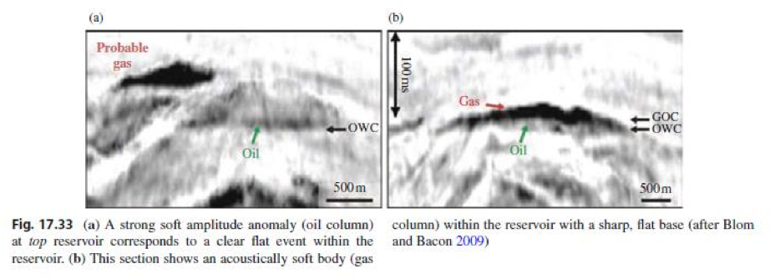

Over the past decades, we have witnessed attribute developments tracking the breakthroughs in reflector acquisition and mapping, fault identification, bright- spot identification, frequency loss, thin-bed tuning, seismic stratigraphy and geomorphology (Fig. 17.33). More recently, interpreters have used cross-plotting to identify clusters of attributes associated with either stratigraphic or hydrocarbon anomalies. Today, very powerful computer workstations capable of integrat- ing large volumes of diverse data and calculating numerous seismic attributes are a routine tool used by seismic interpreters seeking geological and reservoir engineering information from seismic data.

