Drilling program
Based on a given pore/frac pressure prognosis we will try to develop a casing program and highlight important issues that one has to be aware of during drilling of the different well sections and which drilling problems that may occur. The purpose of the exercise is to give an introductory understanding of the process of constructing a well. In an operator company, the major planning document prior to drilling a well is the drilling program.

The case
A subsea vertical exploration will be drilled in order to investigate if there is an oil reservoir in the limestone/dolomite formation seen at the bottom of the geological profile. The water depth is 225 meters (250 meters measured from RKB). A pore pressure prognosis is given below. This is only an estimate of what is expected since this is an exploration well. The reservoir temperature is expected to be around 170 C.
One suspects that there is shallow gas present and some boulders are expected at shallow depths. In some of the shale layers (e.g. in the upper part of Trias) reactive shale can occur. A layer of fractured shale is suspected at around 2700 m.

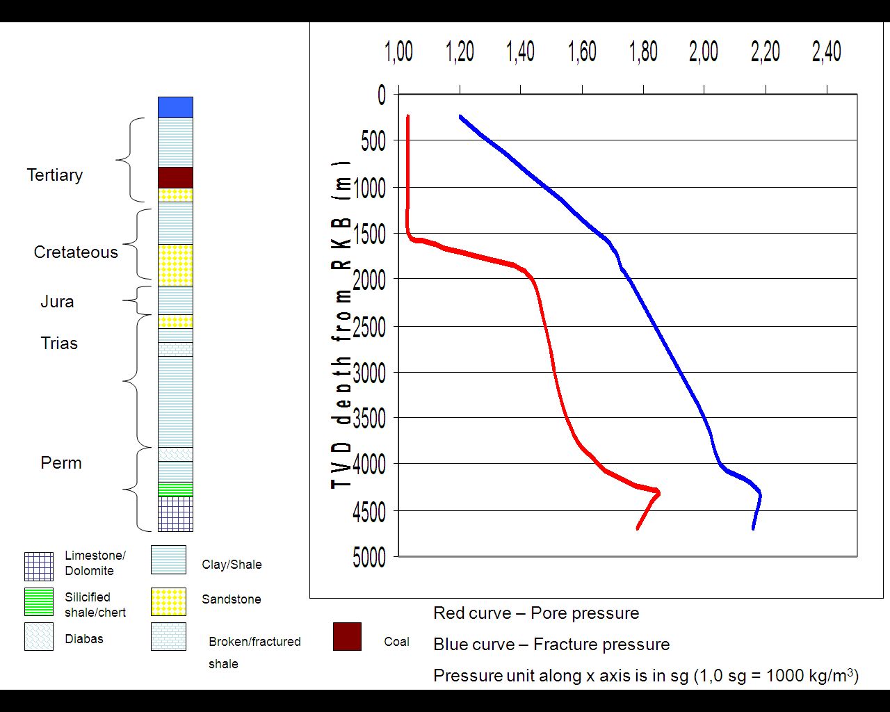

The following hole and casing sizes is planned for the well.
Hole section | Casing size | Setting depth from RKB | Mudweight (s.g.)
36” | 30” | ? | ?
26” | 18 5/8” | ? | ?
Run BOP (Blow out preventor on riser)
17 ½” | 13 3/8” | ? | ?
12 ¼” | 9 5/8” | ? | ?
8 ½” | 7” liner | ? | ?

Questions to be answered
If there information is lacking in the exercises, please make your own assumptions.

Type of well

- Why can this well be classified as an HPHT well (high pressure and high temperature well) ?

The formation temperature is above150 C. At 4300 meter we can see that the pore pressure is around 1.85 sg. This gives us: 4300x1.85x0.0981=780 bar as formation pressure. This will most likely give us a shut in wellhead pressure that is larger than 690 bar. If we assume gas we get: 780-0.03sgx4300x0.0981=767 bar for instance for the shut in wellhead pressure..
The well is classified as an HPHT wells. The large pressure makes well control incidents like e.g. inflow of gas (kick) quite severe and focus is on preventing such incidents (stricter operational procedures)

- What makes an HPHT well challenging with respect to well control?

The large pressure makes well control incidents like e.g. inflow of gas (kick) quite severe and focus is on preventing such incidents (stricter operational procedures). One can expect large kick volumes to surface and large pressures in the well. Equipment can have problem with handling the temperature. Easier to get kick due to small margins. Kick can hide in oil based mud.

Rig
- A double ram rig will be used for the drilling operation. What makes such a rig more efficient than a rig with only one drilling tower (which operations are saved ?) (tip; check out animations at www.seadrill.com)

For instance one tower can make up pipes while the other tower is drilling. One tower can make up and run casing to seafloor so it is ready for being run into the hole while the other tower is drilling.
Preplanning/Casing design.
Casing design and choice of appropriate mudweight for the different hole sections is very important part of the well design process. This often involves computer models and advanced planning. However it is possible to make some simple estimates in advance.

- Try to find out where you will position the different casing shoes and give some arguments for the choices you make. (see table above)

Hole section | Casing size | Setting depth | Mudweight sg
36” | 30” Conductor | 350 m | 1.03 sg
26” | 18 5/8” | 1400 m | 1.15 sg
Run BOP (Blow out preventor on riser)
17 ½” | 13 3/8” | 2900m | 1.57
12 ¼” | 9 5/8” | 4200 | 1.83
8 ½” | 7” liner | TD | 2.0

The 30” surface conductor is usually run 50 – 100 meters into the seabed. Water with bentonite can be used as drilling fluid. The 18 5/8 is set in shale (not sand) and is usually set before the pore pressure increases. Often a KCl brine is used for drilling the 26” section.

The pore pressure at 2900 meters is around 1.5 sg. The fracture pressure at last shoe (18 5/8”) is around 1.63 sg. A mudweight in between could be appropriate for the 17 ½” section i.e. around 1.57 sg. One should try to set the 13 3/8” casing as deep as 2900 meters in order to case of the unstable formations (fractured shale, reactive shale) which is suspected at 2700 meters and above. Then we can omit problems with stuck pipe when continuing drilling the 12 ¼” section.

The 9 5/8” casing is set at 4200 meters in shale. The pore pressure here is around 1.75 sg. The fracture pressure at the last shoe is around 1.9 sg. A mudweight around 1.83-1.85 seems appropriate for the 12 ¼” hole section.

The maximum pore pressure is around 1.85 sg. The fracture pressure at last shoe is 2.15 sg. A mudweight around 2.0 sg will provide a good margin when drilling the final 8 ½” hole.

When choosing an appropriate mudweight we have to take into account the largest of the riser and swab margin, temperature effects and surge pressures. The well pressure must be large enough to avoid potential influxes and low enough to avoid lost circulation. There are also some requirement on how large kick volumes one should be able to take without breaking down the last shoe (kick tolerances). For instance, if a 4m3 kick can not be handled safely from the depth of the planned drilled section without breaking the shoe, one need to drill a shorter section.

- Which mudweights would you choose for the different hole sections and what determines which mudweights we can use ? (see table above)

- What is a kicktolerance and what is it used for ?

During kill circulation, the bottomhole pressure will be kept constant above the pore pressure. This means that the pressure at the last shoe will be Pcas=Pbot-hydrostatic of the fluidmixure between the bottom and the shoe. The more gas in between, the higher pressure. In each hole section there is a minimum limit acceptable for how large kick one should be able to handle before breaking the shoe. If we see we can not handle this, we need to drill a shorter hole section to reduce Ppore such that we get less pressure at the shoe to avoid an underground blowout. This means that kicktolerances can affect the casing design, i.e. where we shall set the different shoes. More on this in a later course.

Top hole sections (36” and 26”)

7) What operational problems/challenges can occur during drilling of the upper sections and what can be done to prevent/reduce these (tools and procedures) ?

Shallow gas. A 9 7/8” pilot hole should be drilled. This will reduce the flow of gas and make it easier to kill the well by .e.g increasing the flowrate and easily increase the friction in the well. ROV’s are also used here to detect gas.
Killmud must be available. LWD tool can be included to detect shallow gas (gamma ray, resisitivity)

Unconsolidated formations: It is important to avoid large washouts. One has to be careful with the flowrate and use a low bit weight. Special care has to be taken in the sand and by e.g. reducing flowrate, omit reaming, omit stationary circulation periods.

Removing formation. Since rather low flowrates are used, high viscosity pills has to be pumped regularly to help removing cuttings/formation and avoid tight spots.

Inclination of conductor: The conductor must have an inclination less than 1 degree since it shall form the fundament for the BOP/wellhead. The boulders we have can cause changes in direction and one must use a low “weight on bit” to reduce the risk. A MWD tool is used in the bottomhole assembly to control the direction. ROV’s are also used to control the inclination of the conductor. Note that it is also easy to get stuck due to the boulders.

Choosing the correct position for the 18 5/8 shoe. This should be set in shale (not e.g. sand) and gammaray equipment can be used to know which formation the casing shoe is placed in. We observe that logging tools can be important also in the upper well sections

- What can you say about cementing of the two upper sections ?

Always semented to top to make the well having a good fundament as possible. All the other casings will hang in the wellhead.

Running Riser and BOP
The blowout preventor (BOP) is run on the riser. The riser connects the BOP and the rig. From this point we have well control and mud returns are taken on the rig.

9) Consult NORSOKD10 and explain which barriers we have in a drilling operation and explain the main difference between the annular preventer and the other rams (pipe, shear).

Primary barrier: Fluid Column
Secondary barrier with barrier elements: casing cement, casing, wellhead, high pressure riser, BOP

Drilling the 17 ½” section
Stuck pipe is known to be a severe event that can be quite expensive and in worst case a fishing operation or a sidetrack can be the final results.

10) Give an overview of different effects that can lead to a stuck pipe incident and what can be done to prevent this ? (also use information given in the case description)

Some answers can be:
Cuttings transport is critical otherwise we can get stuck in the end.. A proper flowrate is required, rotation of drillstring is important. Wiper trips can be used.

Fractured shale. (smart to case it off)
Reactive shale. To reduce the problem with reactive shale an inhibited mud (salt) is required. Oil based mud is better than water based mud. Salt formations are plastic and will move into the hole. In general with unstable formations, it is important to case of these sections as soon as possible. A high mud weight will also be good and reduce the problem.

Geopressured shale - This type of shale has a higher pressure than e.g. nearby sandstones. A higher mudweight is required to drill through these layes

Drilling through different formation types of different hardness can also be problematic. Creating ledges.

Undergauge bit (the size of the bit is reduced which can lead to a smaller hole than one expects when running into hole again)

Differential sticking - mudweight must be reduced.

In general, backreaming is often used to reduce the risk for tight hole conditions.

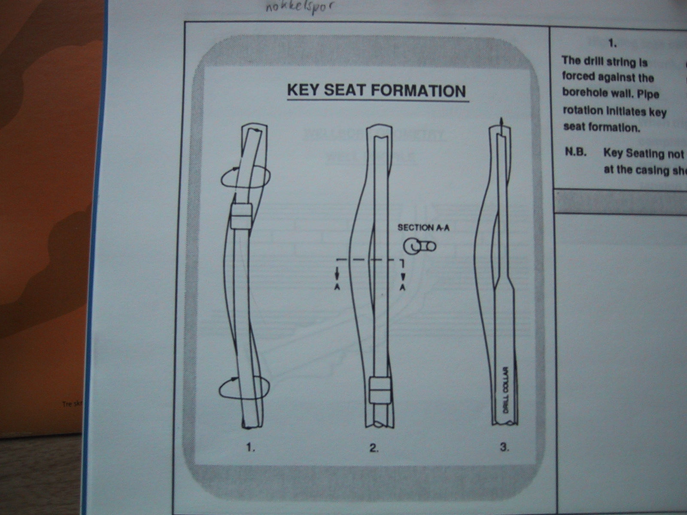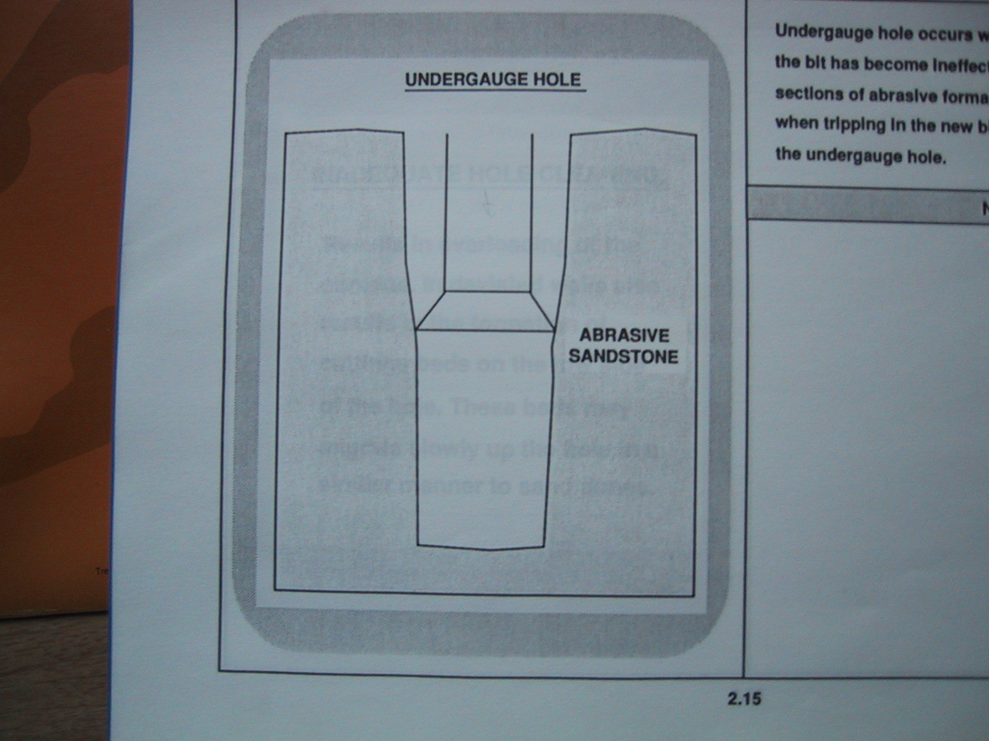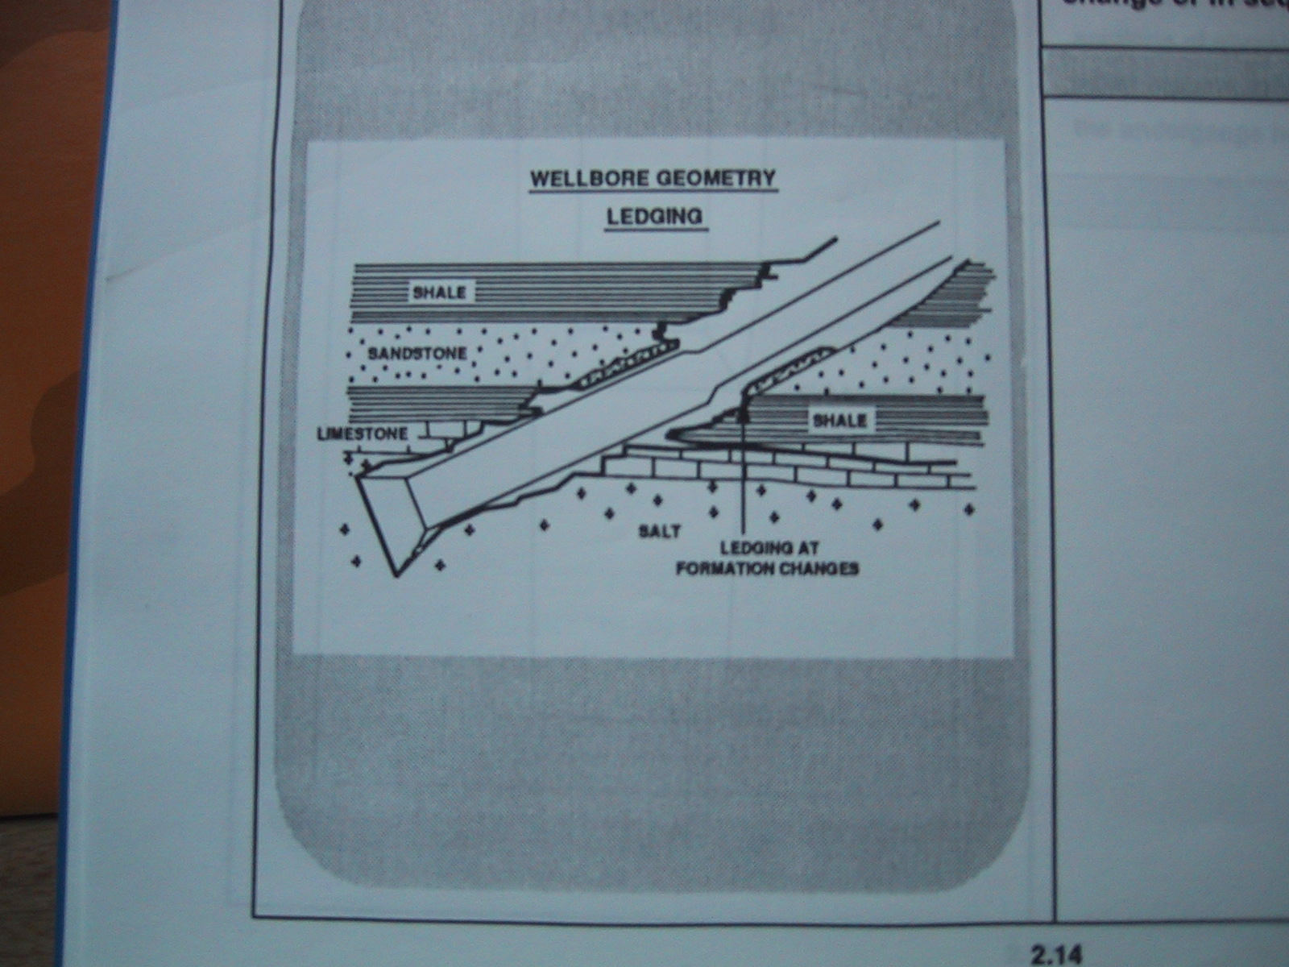

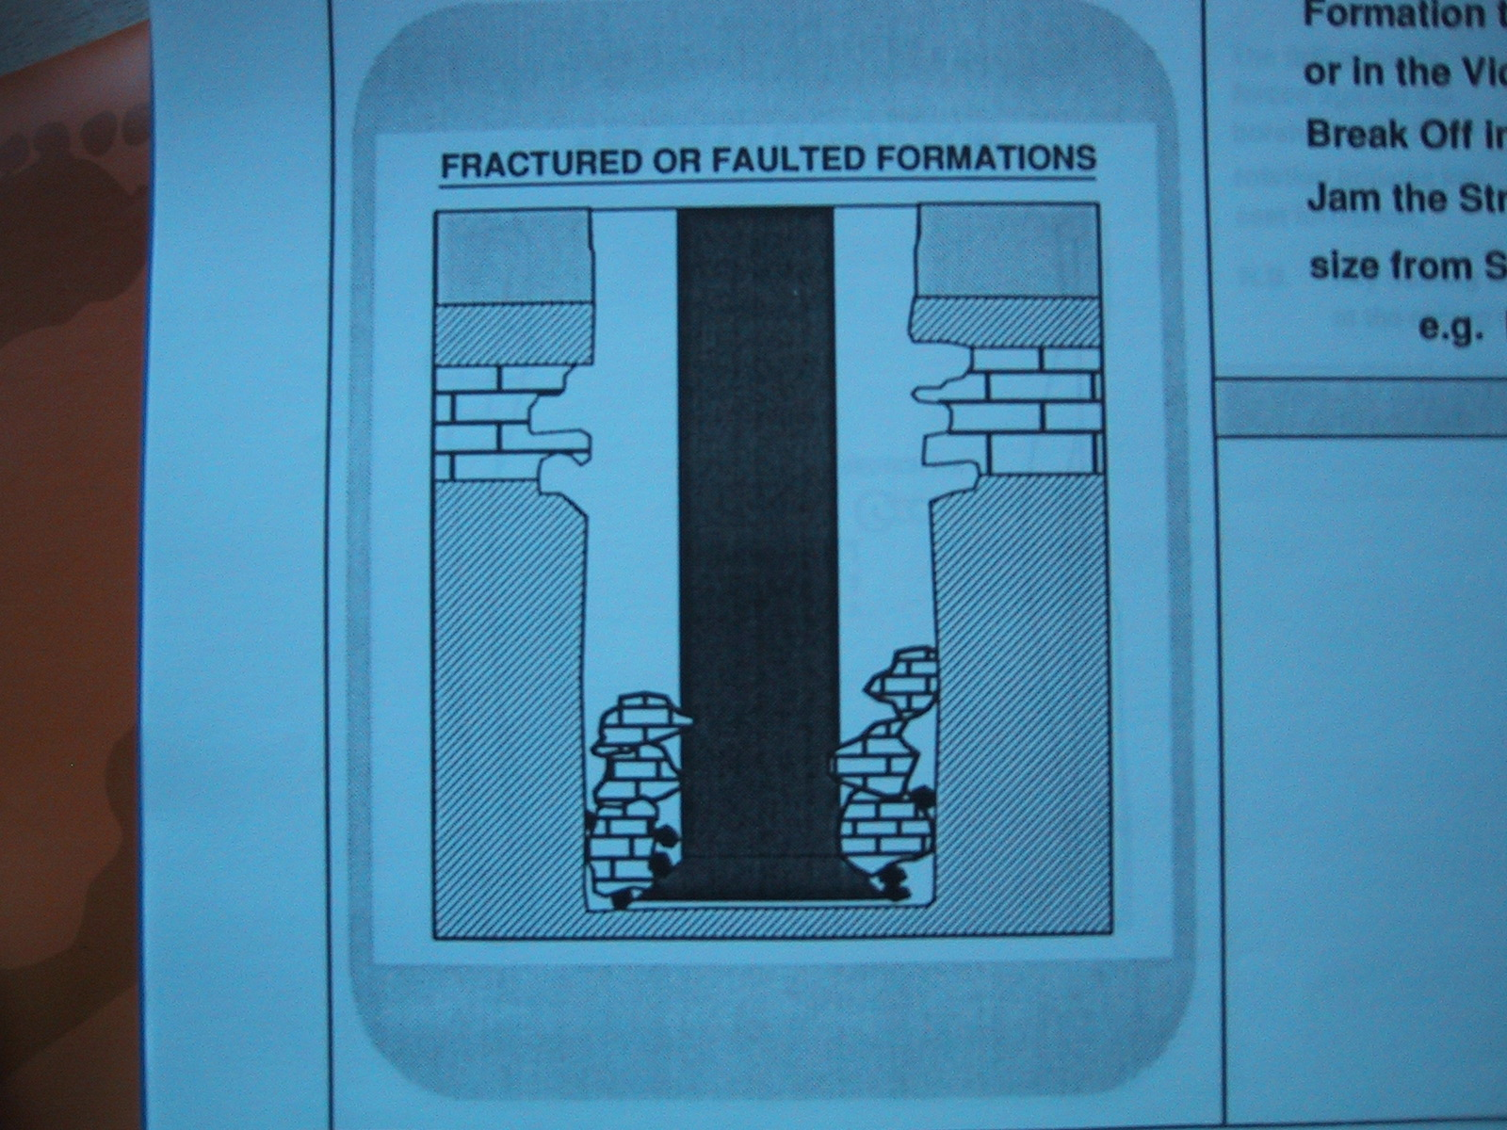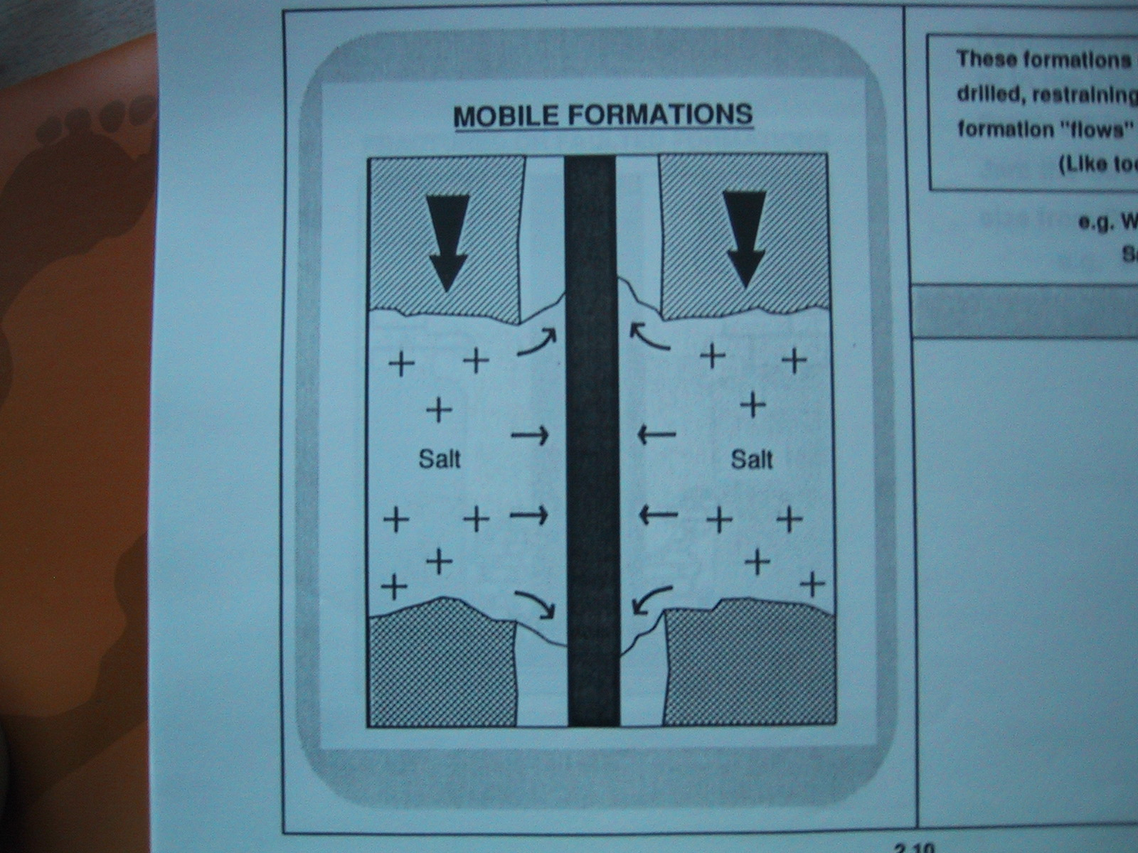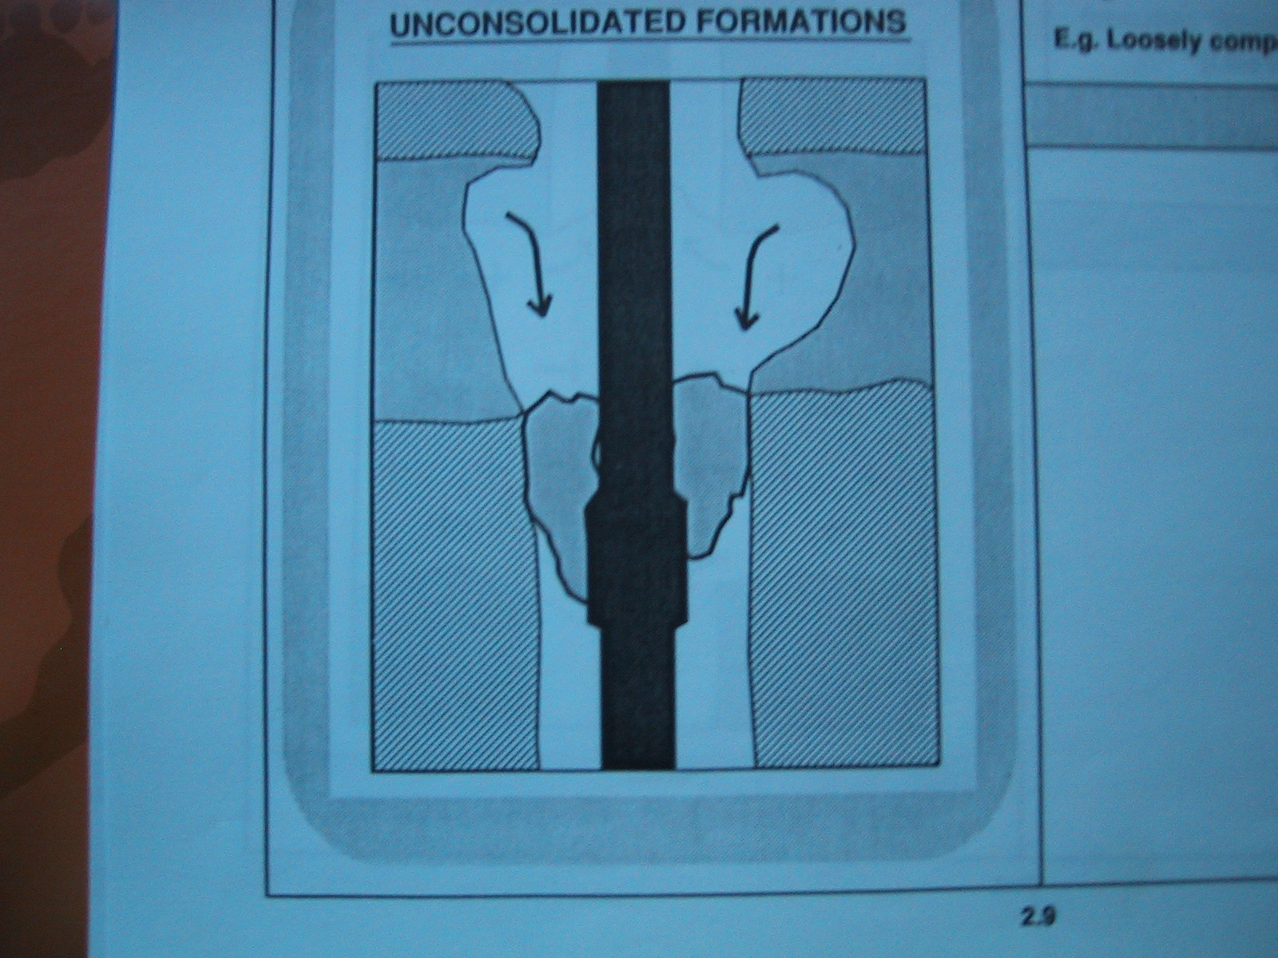

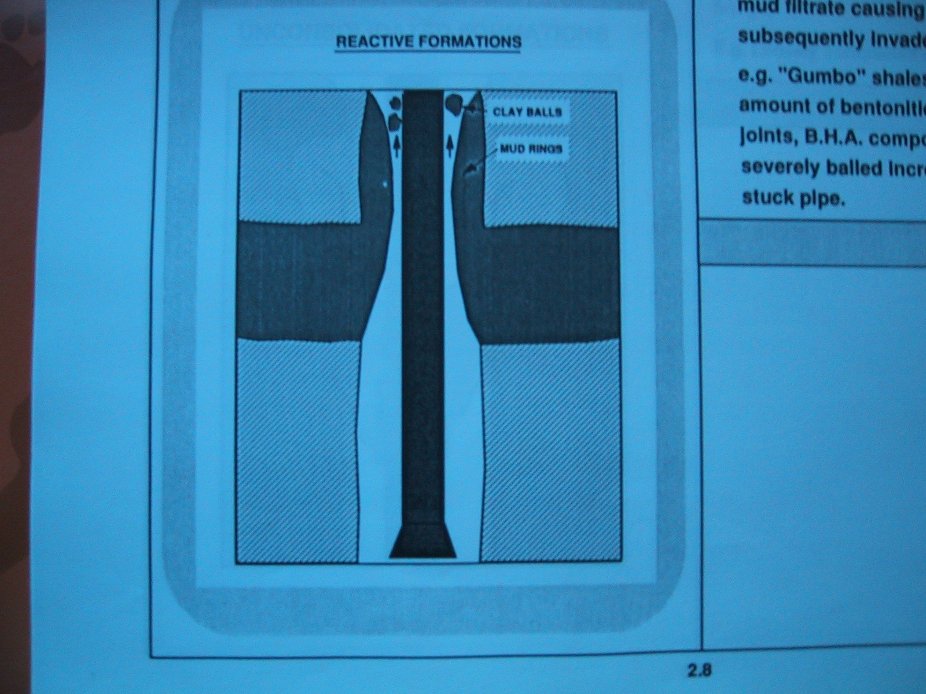

11) Discuss which bits you will use in the different hole sections (roller cone, PDC, hybrid bits and natural diamond bits) and give some advantages/disadvantages associated with each type.

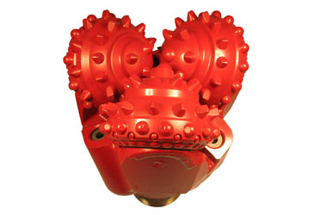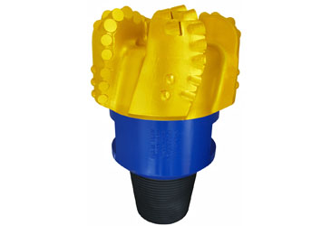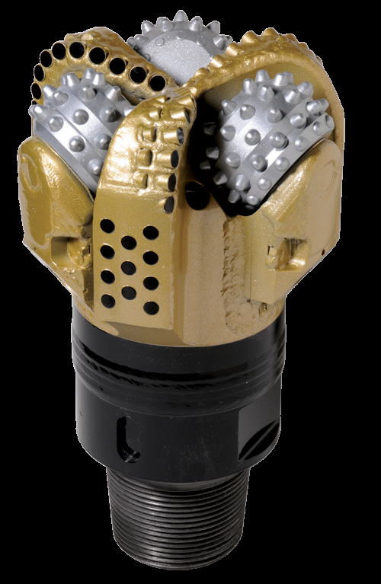
www.nov.com

PDC bit – typically used in soft to medium hard formations. Not applicable in very hard, abrasive formations (e.g. chert, pyritt). Typically used in the lower well sections (12 ¼” and 8 ½”). Often used in combination with a rotary steerable assembly (Autotrak, Powerdrive, Geopilot)
Advantages – faster, no loose parts, fewer trips
Disadvantage – more vibrations, more aggressive - less directional control (remedied by other equipment)
Roller cones- Typically used in the upper sections. Can be used in both soft and harder formations.
Advantages - less vibrations, more directional stable
Disadvantages - Bearings, loose parts, cutters will be worn down, more trips, lower ROP.

In general different things can happen to the bit which makes it necessary to pull out of hole and change bit. Balled up bit caused by e.g. swelling clay is one example, plugged nozzles etc.
In our well we observe some hard formation layers in the lower part of the well. It could be discussed whether a PDC bit is the best choice in this part of the well.

The hybrid bit can be a good compromise if we have varying formations with different hardness. It is reported to be good for interbedded formations, have not so much vibrations and good ROP.

12) After reaching TD of the 17 ½” section, i.e it is time to trip out of the well. The intention is to trip dry by pumping a kill pill into well.

How much is the mud level in the drillpipe reduced if we pump a 2 m3 kill slug into the well with density 1.80 sg. The capacity of the drillpipe is 9,05 l /m. (compare with the length of a stand)

A kill slug of 2 m3 corresponds to a height of 2000 l/9.05l/m = 221 meter. We now set up a pressure balance in the annulus and in the drillstring. Let X be the interface between mud and air in the top part of the drillstring. On bottom we have the following pressures that must be equal: Mudweight and welldepth is taken from casing table further up.
Pann = 1.57x2900x0,0981
Pdrillpipe = 1.57x(2900-221-x)x0,0981+1.80x221x0.0981+0xXx0.0981
Solve the equation Pann = Ptube for x
Should end up with: x = 221x(1.8-1.57)/1.57= 32 meter which is greater than a stand length of around 27 meters. This means that when disconnecting pipe, there will be no mud spills on the rig floor.

Drilling the 12 1/4” and the 8 ½” reservoir section

13) The upper sections are usually drilled with water or a waterbased mud system (WBM). It is common to switch to an oil based mud (OBM) in the lower sections. Discuss some advantages/disadvantages with using OBM in this HPHT well.

OBM. Advantages. Often more compatible with the reservoir formation. Lower ECD’s, improved lubrication, better against reactive clay, reduced risk for differential sticking, more stable at HPHT conditions. Lower max well pressures in case of a kick which reduces the risk for fracturing the formation at the last set casing shoe, gives more time to evaluate the situation before a well control procedure has to be initated.
Disadvantages: More expensive, HSE issues, more difficult to detect kicks since gas will fully dissolve in OBM at HPHT conditons, special procedures have to be implemented to circulate out potential kicks hidden in the oil based mud.

14) An unintended inflow of gas during drilling is called a kick. If this kick is not brought under control a blowout can be the final disastrous results.

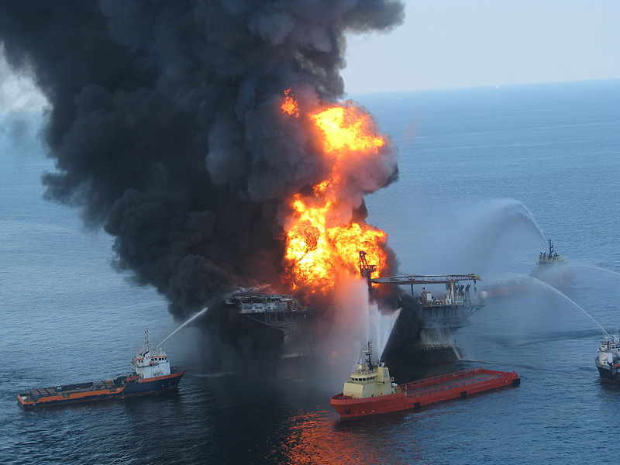
Deepwater Horizon – 21 April 2010.- Gulf of Mexico, www.wikipedia.org

During drilling of the 8 ½” section at around 4300 meters a kick is taken. What can be the reasons for taking a kick and describe briefly the following operational steps.

Reasons for kick could be: Higher pore pressure than predicted, too low mudweight, improper hole fill up, tripping out too fast (swab effect), lost circulation in the 8 ½” section reducing mud level in annulus and thereby reduced pressure in annulus.

The next operational steps is to stop operation, close the BOP, wait until pressures in well have built up and inflow stops. Circulate the kick out through the chokeline and choke and use the choke to control that the bottomhole pressure is kept above the pore pressure to avoid a new kick. A new and heavier mud is then placed in the well to control the pore pressure.

15) Is there any potential for lost circulation in the reservoir section and what consequences can this have ?

There can be fractures, caves in the limestone/dolomite. This increases the risk for lost circulation and a potential well control incident. Important to identify these. Lost circulation can lead to reduced mudlevel in annulus and lead to a kick.

16) Calculate the well pressure drop if 20 m3 of mud is lost in the well during drilling (you can assume that Drillpipe OD is 5”, Riser ID = 19”)

Calculate first the area between the drillpipe OD and the Riser ID. A = 3.14/4x(0,483²-0.127²)= 0.1704 m2. 20 m3 will correspond to a height of 20/0.1704= 117 meter in riser.
The mudweight in 8 ½” is 2.0 sg. The pressure drop in the annulus will be: 117x0.0981x2.0 = 23 bar if we loose 117 meter of mudcolumn. In worst case, this can bring us below the pore pressure and the result will be a kick.

