# Exercise 4 – Directional Well Planning & Calculations

**Exercise 1**

We shall drill a well from a fixed installation in the North Sea. The target coordinates are:

* TVD = 3000 meter
* Northing of target = 479.6 m
* Easting of target = 1100 m

**A:** Calculate the horizontal displacement of the target and the direction of the target !

**B:** The inclination in the sail or hold section shall be constant 45 degrees. The build up rate is 3°/30 meter.

Show that the KOP must be at 1562 meter to fulfill the geometrical requirements. Draw a figure of the well.

**C:** Calculate the measured depth of the well **!**

**D:** At 2500 meter TVD, a casing shoe will be set. Calculate the measured depth for the casing which will be run.

**Exercise 2**

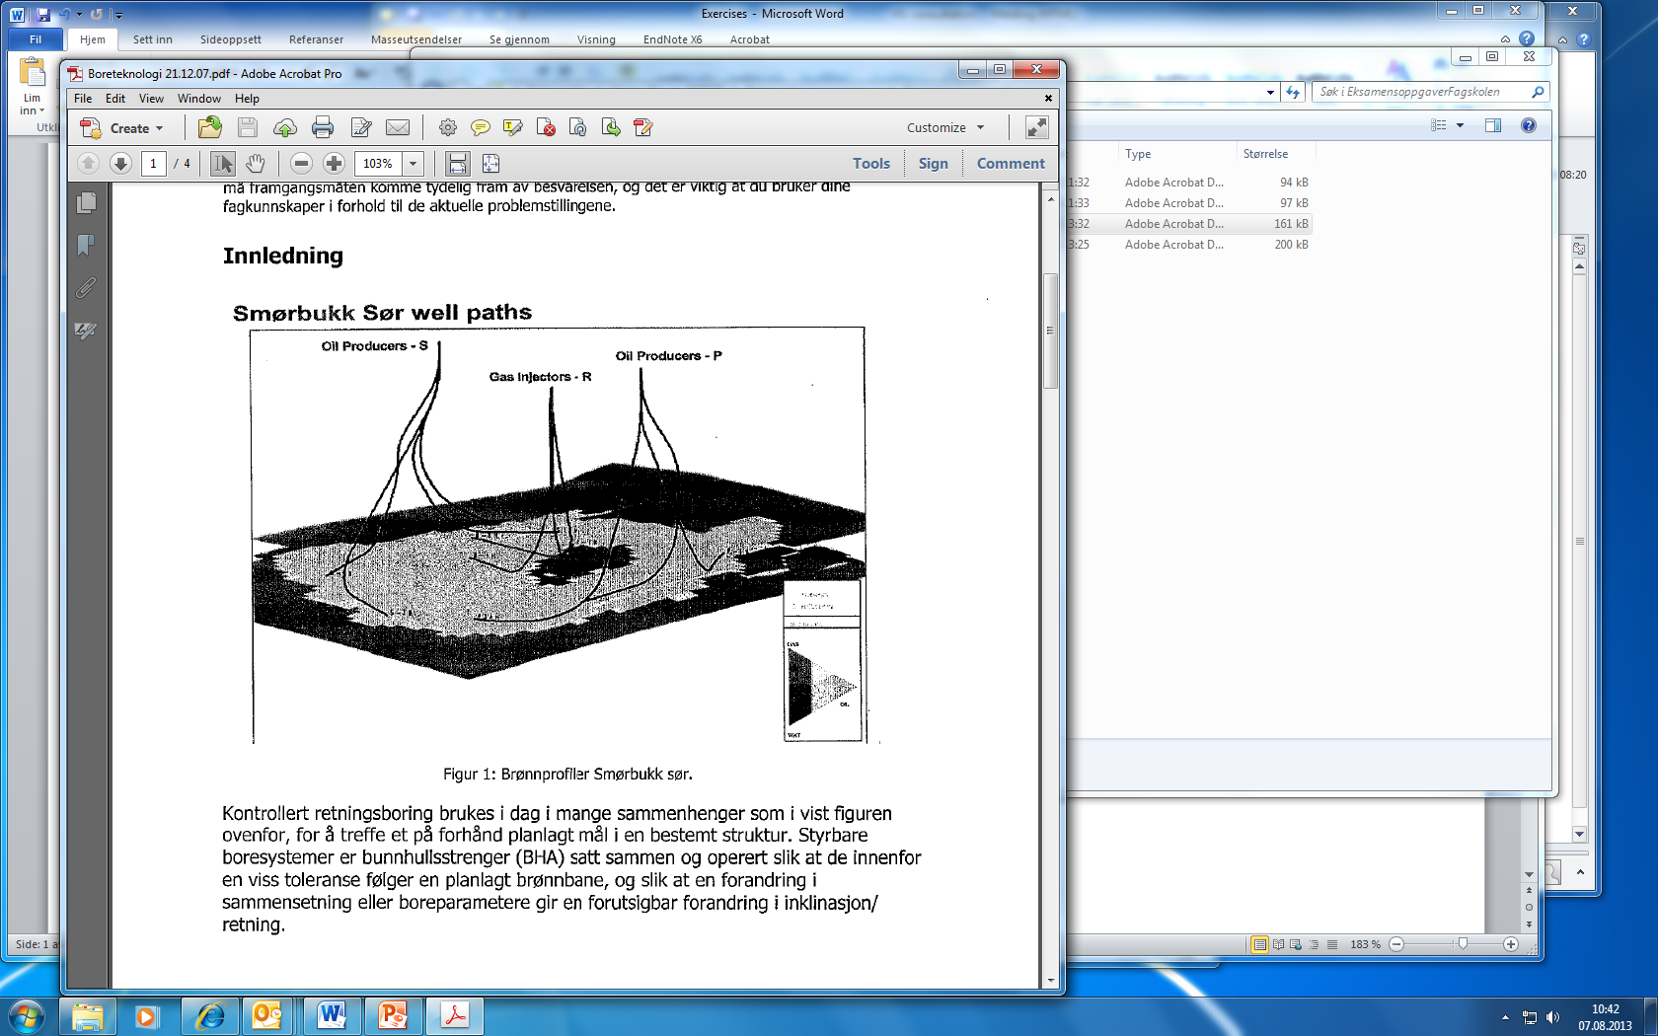

In the following, we will perform calculations for parts of the wellpath for one of the horizontal wells at Smørbukk Sør. This is a wellpath with two kick off points and a schematic of the well path is shown below:

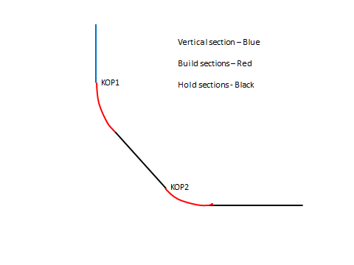

We will perform calculations for reaching target one which is KOP2. The slot coordinates are (NS,ES)=(4.7 m north, 1.5 m east). The target of KOP2 is given by the coordinates: (NT,ET)=(550 m north, 1500 m east). Otherwise:

* KOP2: 3900 m TVD
* KOP1: 1500 m TVD/1500 m MD.
* Build up rate: 

**A:** Calculate the horizontal displacement of the target (KOP2) and the direction (azimuth) of the target !

**B:** Calculate maximum inclination after the first build up !

**C:** What is the horizontal displacement and measured depth after the first build up ?

**D:** Make a sketch of the well and calculate the measured length of the well (until KOP2)

**Exercise 3**

We are planning a S shaped relief well with the following targets:

TVD: 3600 m

North: 1200 m

West: 900 m

**A**: Calculate the horizontal displacement of the target and the direction (azimuth) of the target !

The build up rate is and the drop off rate is . After the drop off section is finished, the inclination shall be zero degrees (vertical) and TVD = 3500 meters. The inclination in the hold section should be constant at 40 degrees.

**B:** How deep must we place the KOP to fulfill the geometrical requirements of the well (make figure)

**C:** What is the measured depth when reaching the target?

**D:** When we have finished the hold section, what is then the measured depth of the well and what are the well coordinates?

# Solutions

**Exercise 1**

**A:** Horizontal displacement is given by H =m (Using Pytagoras). The direction is given by (angle with North is the same as Azimuth)

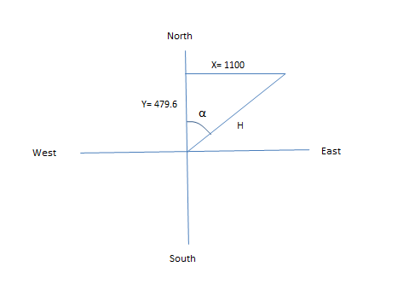

**B:** Always draw a figure first. We shall show that KOP (B) must be at 1562 meters.

We have the following relations  and . From this we can deduce that . In this case R = 573. We have that and . Since , we obtain EC=167 m and BE=405 m. Then . . Note that H is the horizontal displacement found in the first exercise. This gives m. KOP = B = TVD-CF-BE=3000-1033-405 = 1562 m.

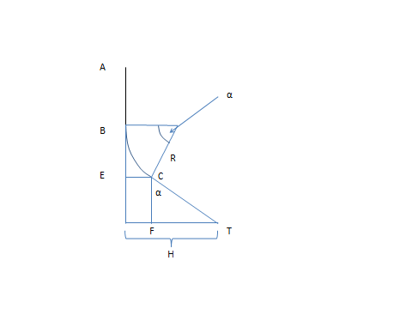

**C:** We have . This gives: . . Measured depth = AB+BC+CT= 1562+450+1461=3473 meters.

**D:** The vertical depth of point C is AB+BE = 1562+405=1967 meter. I.e. the casing shoe will be set between C and T. S = 2500 meter. CS = 2500-AB-BE=2500-1562-405=533 m. . Measured depth of shoe = AB+BC+CR=1562+450+753=2765 m.

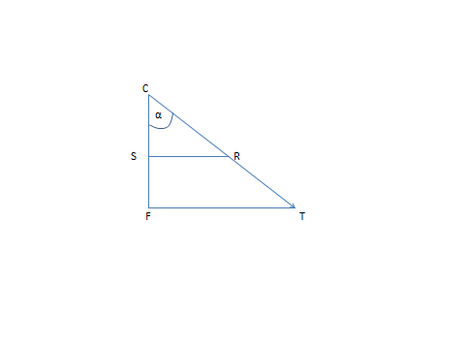

**Exercise 2:**

**A:**  

Direction (azimuth): 

**B:**

In this case, we have to determine the inclination . We observe that so we have to find the angles x and y first. . H =1594.6 m. R =  GT =TVD-AB=3900-1500=2400 m. This gives .

Then we try to find angle y. . PC = R = 1146.5 m. PT can be found by: . This gives . In summary: 

**C:** Horizontal displacement becomes: 



Measured depth becomes: AB+BC =1500+772=2272m.

**D:** FT = H-EC=1594.6-250=1344.6 m. . Measured depth = AB+BC+CT = 1500+772+2155=4427m.

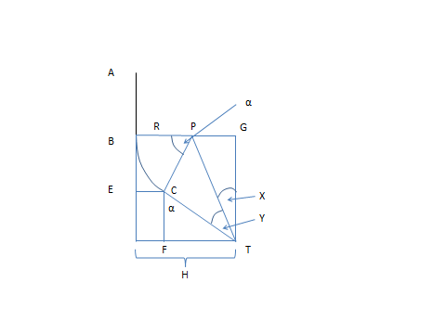

**Exercise 3**

**A:** Horizontal displacement H = 1500 meters. Azimuth = 323.1 degrees (NB remember how azimuth is defined)

**B:**

**First find vertical distances of the arcs**

. . . 

**Then find the horizontal displacements**

**. **



**Use this to find the vertical distance of the hold section.**



**All vertical distances determined. Now the KOP can be determined.**



**C:**

**Find the length of the arcs**, 

**Find the length of the hold section (using Pytagoras)**



Measured depth of target is given by:

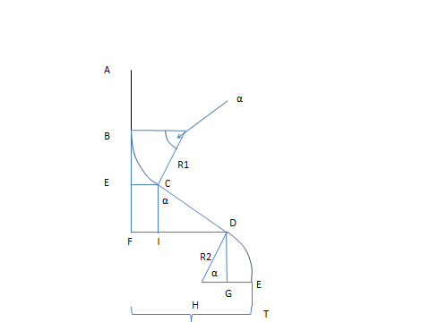

**D:**  Measured depth will be:1190+400+1814=3404m

Horizontal displacement is given by H = EC+ID= 134+1166=1300

West: 

North: 

