**Example Exam PET500 - PART 1: Reservoir Geology (50% Exam)**

**Part 1a: 12 questions (25% Exam)**

1. **Explain the volumetric formula for gas field reserve calculation (surface conditions) and how to estimate the parameters involved.**
2. **Explain how to estimate hydrocarbon reserves (surface conditions) in shale reservoirs. Describe the parameters involved.**
3. **According to Reading and Richards, submarine fans can be divided in 3 systems, what are they and make a brief description of each of them. Which is most likely to characterize North Sea Reservoirs > 80% Net-to-Gross sand?**
4. **What is Basin Modelling? And what are two main purposes of this kind of modelling?**
5. **The precipitation rate of Quartz cementation in sandstone reservoirs is an exponential function of what subsurface parameter and linear function to what another parameter?**
6. **Which are the 4-main petroleum sedimentary basin types, which has the 75% of the world’s conventional oil reserves, and give two reasons why?**
7. **For depositional systems, according to “Walther’s Law”, what generates vertical sequences of sediments?**
8. **From the tectonic illustration below, number and fill in the various basin types (1-3) as well as the mayor causes of subsidence (4-6).**

**1 2 3**

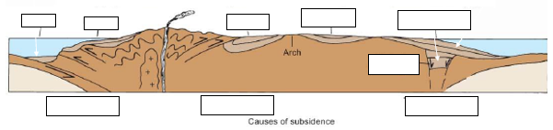

**4 5 6**

1. **GEOPHYSICS/SEISMIC INTERPRETATION RESERVOIRS & FLUIDS**
2. **The figure below shows two seismic datasets acquired at approximately the same location, i.e., for the same part of the subsurface. Describe as fully as you can these two sections and the several differences between them. Your answer should include, but not be limited to:**
3. **The details of what kind of dataset each one is (including what is meant by the annotations on the figures);**
4. **What the zone in the middle (demarcated by the vertical blue lines) represents, and why it looks better on one section than on the other;**
5. **An explanation of the time-scale values on the left.**

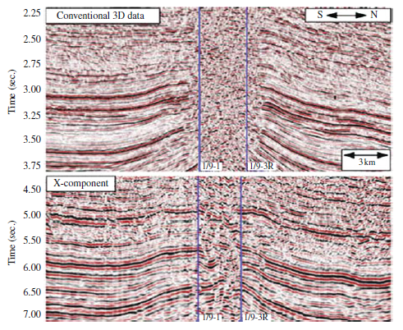

1. **In a similar way, give your own account of what the figure below shows after 11 years of reservoir production history.**

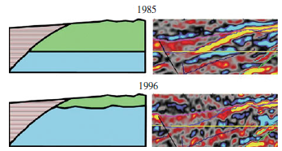

1. **Complete the following Depositional Environment diagram:**

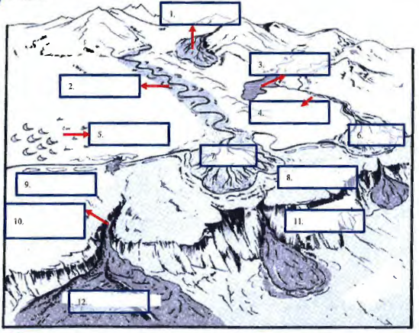

1. **Compare the following for Carbonates vs Sandstones:**

|  |  |  |
| --- | --- | --- |
|  | **Carbonates** | **Sandstones** |
| **Heterogeneity** |  |  |
| **Amount of primary porosity in sediments** |  |  |
| **Amount of ultimate porosity in sediments** |  |  |
| **Permeability-Porosity Interrelation** |  |  |
| **Influence of Diagenesis** |  |  |
| **Percentage of Reservoirs in the world** |  |  |
| **Percentage of HC reserves in the world** |  |  |

1. **The figure below shows the relationship of pressure and temperature for Gulf of Mexico reservoirs. The pressure probabilities for P90, P50 and P10, as a function of temperature are shown as red lines. Divide the diagram into the following areas: NPNT, NPHT, NPLT, HPNT, HPLT, HPHT, where N= Normal, P= Pressure, T= Temperature, H= High, L= Low. Name 2 geological processes which may be responsible for the occurrence of HPHT, and what are pressure and temperature boundaries for HPHT drilling used in the petroleum industry?**

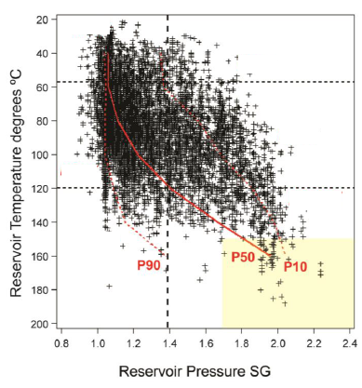

1. **BONUS QUESTION (correct answer will credit an incorrect answer in 1-12).**

**What is it more expensive: a litre of water, a litre of Brent crude oil or a litre of gasoline (bensin) in Norway?**

**Assume the price of a 0.33 litres water bottle is 25 Kroner [Kr]?**

**HINT: State the price of Brent oil barrel, litre of Gasoline and USD/NOK exchange rate dated 18.12.2017, cite your sources.**

**Part 1b (25% of exam):**

1. You have been tasked to estimate the volumes of oil/gas of 3 Norwegian Continental Shelf (NCS) prospects in term of:
2. In-place resources of oil/gas in cubic meters at **reservoir conditions.**
3. Recoverable reserves of oil/gas in cubic meter at **surface conditions**.

You must consider just the oil case for the oil reservoir, just the gas case for the gas reservoir, and both cases for the unknow reservoir. Your employer is mostly interested in high value of **Oil reserves**, and also expects your recommendation of which prospect to prioritize for drilling.

Your subsurface team has provided you with the following information:

|  |  |  |  |  |
| --- | --- | --- | --- | --- |
| **Prospect** | **Water Depth** | **Dimensions** | **Depth Crest** | **Depth Spill Point** |
| 1 | 850 | 20 x 40 km | 2690 | 3010 |
| 2 | 360 | 12 x 20 km | 4600 | 5400 |
| 3 | 235 | 10 x 15 km | 1600 | 1700 |

|  |  |  |  |
| --- | --- | --- | --- |
| **Prospect** | **Reservoir T °C** | **Geological Age** | **Depositional Environment** |
| 1 | 100 | Paleocene | Deep Marine |
| 2 | 170 | Jurassic | Shallow Marine |
| 3 | 75 | Jurassic | Shallow Marine |

Additional information:

**Prospect 1** has a strong flat seismic feature near the mapped spill.

**Prospect 2** has no data available.

**Prospect 3** has a very weak flat seismic feature near the spill point.

**Tasks:**

* **State the reservoir analogue.**
* **Do the calculation clearly.**
* **State your further plan of development (what to do, prioritization, proposed production scenarios).**

1. **A Norwegian Arctic shelf prospect has been identified at 1.5 Km depth. Pressure of the reservoir is estimated to be 150 bar (hydrostatic gradient). Basin modelling indicates that the prospect was charged fill to spill during maximum burial at 3 Km depth, with a reservoir pressure of 300 bar. Estimates are that the reservoir initially contains 100 Million m3 of oil and 100 million m3 of gas, at reservoir conditions during maximum burial. Assuming that the prospect area has undergone 1.5 Km of uplift and erosion, what would the estimated volumes of oil and gas in the uplifted reservoir be today assuming that the trap volume and relative spill point are unchanged? Briefly Explain.**